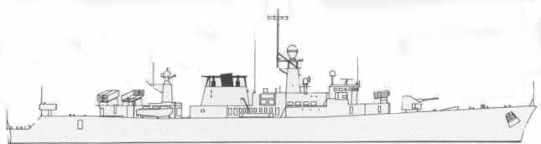
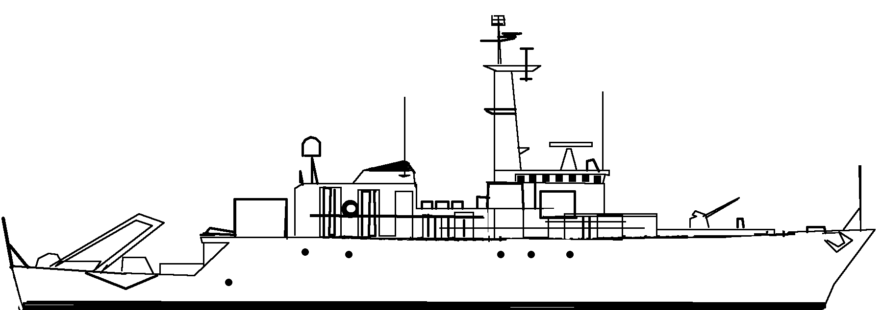
WESTDEIP. Frigate F 911 2.5 STF
SystemSAFRGLADFADFCADPDFASW1100mm29--1--2375mm RL101----D4Sonar+2. +3 if using towed sonar.3ECM-----3-4EXOCET MM3820/860-----Nato RIM7M
Seasparrow2AB15--14Hi/Vlo5ASW Torp76----D6AW Radar3------6SW Radar3------ASW TorpsPort12Stbd12L5Moves MAA12345MTF -0Exocet.Port12Stbd12MTF -3FIREFLOODINGHELMELECTRICAL.
NOISE +0
25kn2015105SUNK
Nixie Torpedo Decoy. -3
21kn1812105SUNK
NOISE -2
SystemSAFRGLADFADFCADPDFASW120 mm AA12---1-2SW Radar23AW Radar24SONAR.+3 mine hunting sonar.5Stinger.-1---2-6HMG.1. 5---1-Uses sonar to detect mines in waters up to 80 metres deep.
Can tow a minesweeping sled, or normal sweep.
2 PAP 104 MkIV remote controlled mine hunters are carried.FIREFloodingHELMElectronics.
ASW DECOY -2
WIELINGEN. Frigate F 910 2.5 STF
SystemSAFRGLADFADFCADPDFASW1100mm29--1--2375mm RL101----D4Sonar+2. +3 if using towed sonar.3ECM-----3-4EXOCET MM3820/860-----Nato RIM7M
Seasparrow2AB15--14Hi/Vlo5ASW Torp76----D6AW Radar3------6SW Radar3------ASW TorpsPort12Stbd12L5Moves MAA12345MTF -0Exocet.Port12Stbd12MTF -3FIREFLOODINGHELMELECTRICAL.
25kn2015105SUNK
Nixie Torpedo Decoy. -3
NOISE +1
ASTER M915 .5 STF
21kn1812105SUNK
NOISE -2
SystemSAFRGLADFADFCADPDFASW120 mm AA12---1-2SW Radar23AW Radar24SONAR.+3 mine hunting sonar.5Stinger.-1---2-6HMG.1. 5---1-Uses sonar to detect mines in waters up to 80 metres deep.
Can tow a minesweeping sled, or normal sweep.
2 PAP 104 MkIV remote controlled mine hunters are carried.FIREFloodingHELMElectronics.
ASW DECOY -2
BELLIS M916 .5 STF
21kn1812105SUNK
NOISE -2
SystemSAFRGLADFADFCADPDFASW120 mm AA12---1-2SW Radar23AW Radar24SONAR.+3 mine hunting sonar.5Stinger.-1---2-6HMG.1. 5---1-Uses sonar to detect mines in waters up to 80 metres deep.
Can tow a minesweeping sled, or normal sweep.
2 PAP 104 MkIV remote controlled mine hunters are carried.FIREFloodingHELMElectronics.
ASW DECOY -2
CROCUS M917 .5 STF


