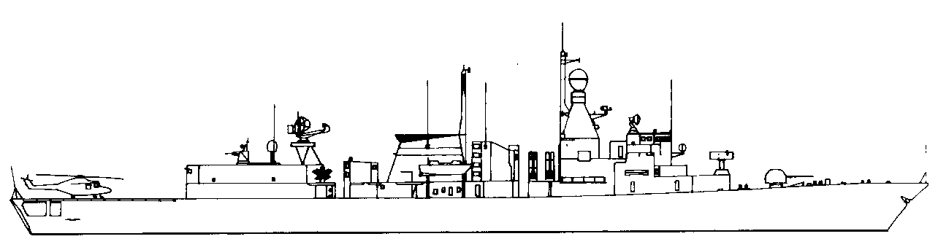
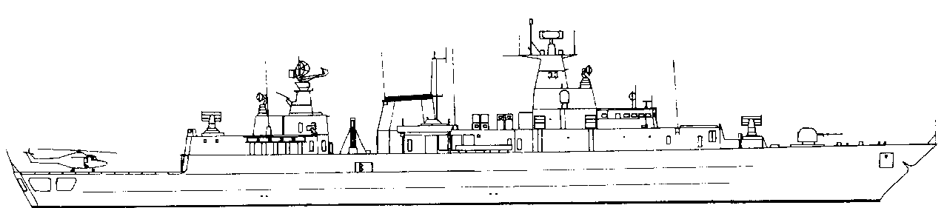

EMDEN (1983). F210 3 STF
F807 3 STF
SystemSAFRGLADFADFCADPDFASW1Goalkeeper24---6(1991)2Harpoon Pt20/860-----3Sonar+2. +3 if using towed sonar.4ECM----14576mmOTO24--31Hi/Vlo6Harpoon Stbd20/860-----7ASWtorps76----D6AWRadar48SW Radar49Nato RIM7M
Seasparrow2AB15--14Hi/Vlo0ASWtorps0/76----D6ASW TorpsPort123Stbd123Mk46Moves MAA12345678MTF-2HelicopterSea LynxASW type.HARPOONPort1234Stbd1234MTF -3FIREFloodingHelmElectronicsHangarFLIGHT DECK.
30kn2520105SUNK
ASW DECOY -3
NOISE +0
BREMEN (1982). F207 3 STF
F807 3 STF
SystemSAFRGLADFADFCADPDFASW1Goalkeeper24---6(1991)2Nato RIM7M
Seasparrow VLS2AB15--14Hi/Vlo.3Sonar+2. +3 if using towed sonar.4ECM----14576mmOTO24--31Hi/Vlo6Harpoon Stbd20/860-----7ASWtorps76----D6AWRadar48SW Radar49RAM0ASWtorps0/76----D6ASW TorpsPort123Stbd123Mk46Moves MAA12345678MTF-2HelicopterSea LynxASW type.HARPOONPort1234Stbd.1234MTF -3FIREFloodingHelmElectronicsHangarFLIGHT DECK.
30kn2520105SUNK
ASW DECOY -3
NOISE +0
RHEINLAND PFALZ (1983). F209. 3 STF
F807 3 STF
SystemSAFRGLADFADFCADPDFASW1Goalkeeper24---6(1991)2Harpoon Pt20/860-----3Sonar+2. +3 if using towed sonar.4ECM----14576mmOTO24--31Hi/Vlo6Harpoon Stbd20/860-----7ASWtorps76----D6AWRadar48SW Radar49Nato RIM7M
Seasparrow2AB15--14Hi/Vlo0ASWtorps0/76----D6ASW TorpsPort123Stbd123Mk46Moves MAA12345678MTF-2HelicopterSea LynxASW type.HARPOONPort12Stbd.12MTF -3FIREFloodingHelmElectronicsHangarFLIGHT DECK.
30kn2520105SUNK
ASW DECOY -3
NOISE +0
BRANDENBURG (2003). F215 4. STF
F807 3 STF
SystemSAFRGLADFADFCADPDFASW1RAM-2--14-220mmRh202.51---1-3Sonar+2. +3 if using towed sonar.4ECM----25-576mmOTO24--31Hi/Vlo6EXOCET MM3820/860-----7ASWtorps76----D6AWRadar48SW Radar49Seasparrow VLS2AB15--14Hi/Vlo0ASWtorps0/76----D6ASW TorpsPort123Stbd123Mk46Moves MAA12345678MTF-3Helicopter2 x Sea LynxASW type.EXOCETPort1234Stbd.1234MTF -3FIREFloodingHelmElectronicsHangarFLIGHT DECK.
30kn2515105SUNK
ASW DECOY -3
NOISE -1
WEST GERMANY
SASCHEN (2003). F219 5.5 STF
F807 3 STF
SystemSAFRGLADFADFCADPDFASW1OTO 76mmSR34--43-220mm MLG27.51---2-SM-2-MR3AB30556-3Sonar+2. +3 if using towed sonar.4ECM----25-RAM-2--14-576mmOTO24--31Hi/Vlo6HARPOON25130-----7ASWtorps76----D6AWRadar48SW Radar49Evolved Seasparrow2AB21-256Hi/Vlo0RAM-2--14-ASW TorpsPort123Stbd123Mk46Moves MAA123456789MTF-4Helicopter2 x Sea LynxASW type.HARPOON.Port1234Stbd.1234MTF -4FIREFloodingHelmElectronicsHangarFLIGHT DECK.
29kn2520105SUNK
ASW DECOY -4
NOISE -2
HAMBURG (2003). F220 5.5 STF
F807 3 STF
SystemSAFRGLADFADFCADPDFASW1OTO 76mmSR34--43-220mm MLG27.51---2-SM-2-MR3AB30556-3Sonar+2. +3 if using towed sonar.4ECM----25-RAM-2--14-576mmOTO24--31Hi/Vlo6HARPOON25130-----7ASWtorps76----D6AWRadar48SW Radar49Evolved Seasparrow2AB21-256Hi/Vlo0RAM-2--14-ASW TorpsPort123Stbd123Mk46Moves MAA123456789MTF-4Helicopter2 x Sea LynxASW type.HARPOON.Port1234Stbd.1234MTF -4FIREFloodingHelmElectronicsHangarFLIGHT DECK.
29kn2520105SUNK
ASW DECOY -4
NOISE -2
SystemSAFRGLADFADFCADPDFASW1OTO 76mmSR34--43-220mm MLG27.51---2-SM-2-MR3AB30556-3Sonar+2. +3 if using towed sonar.4ECM----25-RAM-2--14-576mmOTO24--31Hi/Vlo6HARPOON25130-----7ASWtorps76----D6AWRadar48SW Radar49Evolved Seasparrow2AB21-256Hi/Vlo0RAM-2--14-ASW TorpsPort123Stbd123Mk46Moves MAA123456789MTF-4Helicopter2 x Sea LynxASW type.HARPOON.Port1234Stbd.1234MTF -4FIREFloodingHelmElectronicsHangarFLIGHT DECK.
29kn2520105SUNK
WEST GERMANY
HESSEN (2003). F221 5.5 STF
F807 3 STF

ASW DECOY -4

NOISE -2
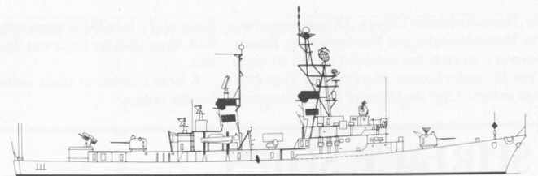
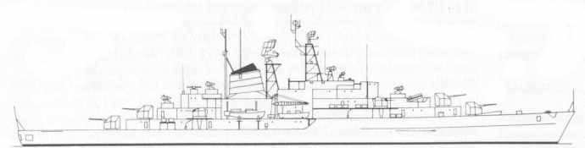
ROMMEL (as 1981). DDG-187 3 STF
F807 3 STF
32kn2520105SUNK
NO ASW DECOY
SystemSAFRGLADFADFCADPDFASW15” Mk42313--31-2SM-1-MR3AB20-44--3Sonar+1 4ECM-----3-5ASWtorps76----D66HARPOON25130-----7AW Radar38SW Radar49ASROCD605” Mk42313--31-ASW TorpsPort123Stbd123Mk46Moves MAA123456789101112MTF-4HARPOON.Port1234Fired from SAM launcherMTF -4FIREFloodingHelmElectronics
NOISE +2
LUTJENS (as 1981). DDG-185 3 STF
F807 3 STF
32kn2520105SUNK
NO ASW DECOY
SystemSAFRGLADFADFCADPDFASW15” Mk42313--31-2SM-1-MR3AB20-44--3Sonar+1 4ECM-----3-5ASWtorps76----D66HARPOON25130-----7AW Radar38SW Radar49ASROCD605” Mk42313--31-ASW TorpsPort123Stbd123Mk46Moves MAA123456789101112MTF-4HARPOON.Port1234Fired from SAM launcherMTF -4FIREFloodingHelmElectronics
NOISE +2
MOLDERS (as 1981). DDG-186 3 STF
F807 3 STF
32kn2520105SUNK
NO ASW DECOY
SystemSAFRGLADFADFCADPDFASW15” Mk42313--31-2SM-1-MR3AB20-44--3Sonar+1 4ECM-----3-5ASWtorps76----D66HARPOON25130-----7AW Radar38SW Radar49ASROCD605” Mk42313--31-ASW TorpsPort123Stbd123Mk46Moves MAA123456789101112MTF-4HARPOON.Port1234Fired from SAM launcherMTF -4FIREFloodingHelmElectronics
NOISE +2
22kn2015105SUNK
DEUTSCHLAND (as 1981). DDG-186 5 STF

3 STF
F807 3 STF
NO ASW DECOY
SystemSAFRGLADFADFCADPDFASW1100mm29--1--2100mm29--1--3Sonar+1. 4ECM-----3-40mm twin12--115ASWtorps76----D66100mm29--1--7AW Radar38SW Radar49375mm RL0/101----D440mm twin12--110100mm29--1--ASW TorpsPort123Stbd123Mk46FIREFloodingHelmElectronics
NOISE +2
Cruiser type training ship, with wartime combat capability.
WEST GERMANY
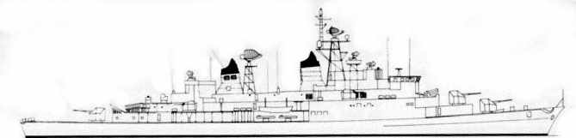
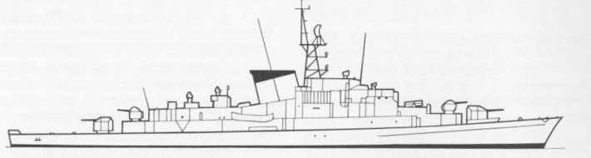
HESSEN (as 1980). DD-184 3.5 STF

3 STF
F807 3 STF
35kn3020155SUNK
NO ASW DECOY
SystemSAFRGLADFADFCADPDFASW1100mm29--1--2100mm29--1--3Sonar+1. 4ECM-----3-40mm twin12--115ASWtorps76----D66EXOCET MM3820/860-----7AW Radar38SW Radar49375mm RL0/101----D440mm twin12--110100mm29--1--ASW TorpsPort123Stbd123Mk46EXOCET1234MTF -4FIREFloodingHelmElectronics
NOISE +2
BAYERN (as 1980). DD-183 3.5 STF

3 STF
F807 3 STF
35kn3020155SUNK
NO ASW DECOY
SystemSAFRGLADFADFCADPDFASW1100mm29--1--2100mm29--1--3Sonar+1. 4ECM-----3-40mm twin12--115ASWtorps76----D66EXOCET MM3820/860-----7AW Radar38SW Radar49375mm RL0/101----D440mm twin12--110100mm29--1--ASW TorpsPort123Stbd123Mk46EXOCET1234MTF -4FIREFloodingHelmElectronics
NOISE +2
35kn3020155SUNK
LUBECK. (as 1980). F224 2.5 STF

3 STF
F807 3 STF
NO ASW DECOY
SystemSAFRGLADFADFCADPDFASW1100mm29--1--240mm twin12--11-3Sonar+1. 4ECM-----2-Mine rails.-------5ASWtorps76----D6640mm Single12---17AW Radar38SW Radar49375mm RL0/101----D440mm twin12--11-0100mm29--1--ASW TorpsPort123Stbd123Mk46FIREFloodingHelmElectronics
NOISE +2
WEST GERMANY
 | 35kn | 30 | 20 | 15 | 5 | SUNK

AUGSBERG. (as 1980). F222 2.5 STF

3 STF
F807 3 STF

NO ASW DECOY
 | System |  | SAF | RG |  |  |  | LADF |  |  | ADF |  |  | CAD |  |  |  |  | PDF |  | ASW
1 | 100mm |  | 2 | 9 |  |  |  | - |  |  | - |  | 1 |  |  |  |  |  | - |  | -
2 | 40mm twin |  | 1 | 2 |  |  |  | - |  |  | - |  | 1 |  |  |  |  |  | 1 |  | -
3 | Sonar |  | +1.
4 | ECM |  | - | - |  |  |  | - |  |  | - |  | - |  |  |  |  |  | 2 |  | -
4 | Mine rails. |  | - | - |  |  |  | - |  |  | - |  | - |  |  |  |  |  | - |  | -
5 | ASWtorps |  | 7 | 6 |  |  |  | - |  |  | - |  | - |  |  |  |  |  | - |  | D6
6 | 40mm Single |  | 1 | 2 |  |  |  | - |  |  | - |  | 1 |  |  |  |  |  | 1
7 | AW Radar |  | 3
8 | SW Radar |  | 4
9 | 375mm RL |  | 0/10 | 1 |  |  | - |  |  |  | - |  | - |  |  |  |  | - |  |  | D4
9 | 40mm twin |  | 1 | 2 |  |  | - |  |  |  | - |  | 1 |  |  |  |  | 1 |  |  | -
0 | 100mm |  | 2 | 9 |  |  | - |  |  |  | - |  | 1 |  |  |  |  | - |  |  | -
ASW Torps |  |  | Port | 1 | 2 | 3 |  |  | Stbd |  |  | 1 |  |  | 2 |  | 3 |  |  | Mk46
FIRE |  | Flooding |  |  |  |  |  |  |  | Helm |  |  |  |  |  | Electronics

NOISE +2
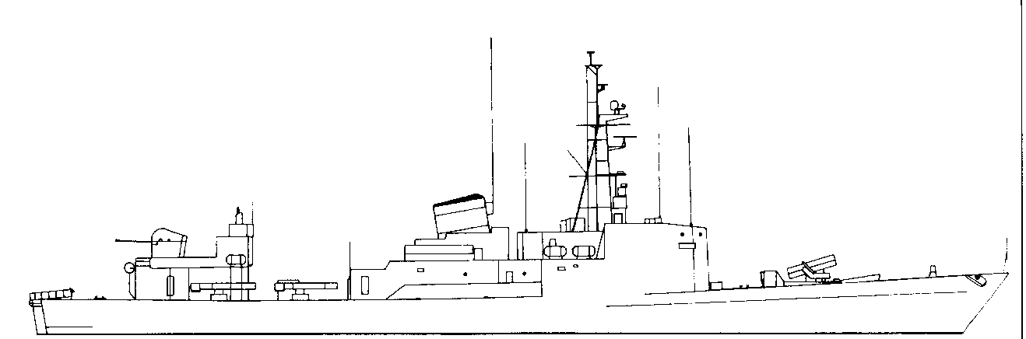
23kn2015105SUNK
THETIS. (as 1980). P6052 .5 STF

3 STF
F807 3 STF
NOISE +2
NO ASW DECOY
SystemSAFRGLADFADFCADPDFASW140mm twin12--11-2Sonar+1. 3ECM-----2-Mine rails.-------4ASWtorps76----D65375mm RL0/101----D46SW Radar4ASW TorpsPort123Stbd123Mk46FIREFloodingHelmElectronics
23kn2015105SUNK
THESEUS. (as 1980). P6056 .5 STF

3 STF
F807 3 STF
NOISE +2
NO ASW DECOY
SystemSAFRGLADFADFCADPDFASW140mm twin12--11-2Sonar+1. 3ECM-----2-Mine rails.-------4ASWtorps76----D65375mm RL0/101----D46SW Radar4ASW TorpsPort123Stbd123Mk46FIREFloodingHelmElectronics
WEST GERMANY

