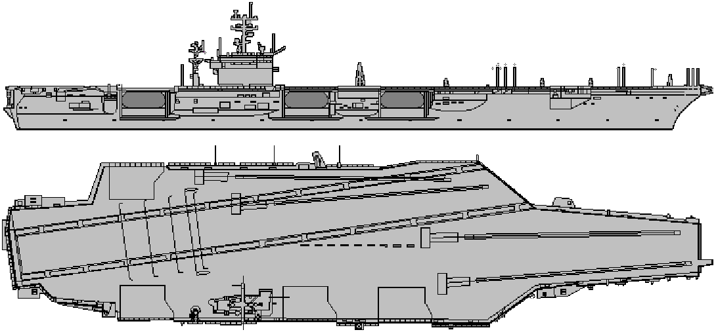
AIRCRAFT AND HELICOPTERS.
SEAKING HELICOPTERS | 1 | 2 | 3 | 4 |  |  | 5 |  |  |  | AD 3 ECM 1 |  |  |  |  |  |  |  |  |  |  |  | 4 x ASW Torpedoes. Or 4 Depth Charges.
F-14A TOMCAT | 1 | 2 | 3 | 4 |  |  | 5 |  | 6 |  | 7 |  | 8 |  | 9 |  | 10 |  | 11 |  | 12 |  | AD8/4  EW 2 | Fighter.
F-14A TOMCAT | 1 | 2 | 3 | 4 |  |  | 5 |  | 6 |  | 7 |  | 8 |  | 9 |  | 10 |  | 11 |  | 12 |  | AD8/4  EW 2
F-18C HORNET | 1 | 2 | 3 | 4 |  |  | 5 |  | 6 |  | 7 |  | 8 |  | 9 |  | 10 |  | 11 |  | 12 |  | AD 9/4  EW 3 | x 250kg bombs. Or 2 Harm, or 2 x Harpoon. Or 2 Maverick.
F-18 | 1 | 2 | 3 | 4 |  |  | 5 |  | 6 |  | 7 |  | 8 |  | 9 |  | 10 |  | 11 |  | 12 |  | AD 9/4  EW 3
A-6E | 1 | 2 | 3 | 4 |  |  | 5 |  | 6 |  | 7 |  | 8 |  | 9 |  | 10 |  |  |  |  |  | AD 4/2  EW 2 | 8 x 250kg bombs. 5 x 750kg bombs. 4 Harpoon etc.
S-3 VIKING | 1 | 2 | 3 | 4 |  |  | 5 |  | 6 |  | 7 |  | 8 |  | 9 |  | 10 |  |  |  |  |  | AD2/1  EW 2 | 4 ASW Torps. Or 2 Harpoon, or 6 x 750kg LGB.
KA-6D | 1 | 2 | 3 | 4 |  |  |  |  |  |  |  |  |  |  |  |  |  |  |  |  |  |  | AD 4/1  ECM - | IN FLIGHT TANKER.
EA6B PROWLER | 1 | 2 | 3 | 4 |  |  | 5 |  |  |  |  |  |  |  |  |  |  |  |  |  |  |  | AD4  EW 6 | 4 to 6 HARM.
E2C HAWKEYE | 1 | 2 | 3 | 4 |  |  |  |  |  |  |  |  |  |  |  |  |  |  |  |  |  |  | AD 1  ECM 2 | AIRBORNE EARLY WARNING
Moves MAA | 1 | 2 | 3 |  | 4 | 5 |  | 6 |  | 7 |  | 8 |  | 9 |  | 10 |  | 11 |  | 12 |  | MTF -2

FIRE | FLOODING | HELM | ELECTRIC SYSTEM. | HANGAR | FWD  FLIGHT  DECK | AFT  FLIGHT  DECK | ANGLED  DECK | LIFT  1 | LIFT  2 | LIFT  3 | LIFT  4
 |  |  |  | HANGAR

35 knots | 25 knots | 15 knots | 10 knots | 5 knots | sunk

ASW DECOYS. -4

 | System | SAF  HIT | RG | LR  ADF | ADF | CAD | PDF
1 | SEASPARROW | 2AB/ 5 | 12 | - | - | 2 | 4
2 | SW RADAR | +6 |  | - | - | - | -
3 | PHALANX | - | - | - | - | - | 5
4 | ECM. | - | - | - | - | - | 6
5 | AW. Radar | +6 |  | - | - | - | -
5 | PHALANX | - | - | - | - | - | 5
6 | SEASPARROW | 2AB/ 5 | 12 | - | - | 2 | 4

USS NIMITZ CVN 68 55 CVN

NOISE RATING. +4
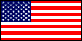
 | System | SAF  HIT | RG | LR  ADF | ADF | CAD | PDF
1 | SEASPARROW | 2AB/ 5 | 12 | - | - | 2 | 4
2 | SW RADAR | +6 |  | - | - | - | -
3 | PHALANX | - | - | - | - | - | 5
4 | ECM. | - | - | - | - | - | 6
5 | AW. Radar | +6 |  | - | - | - | -
5 | PHALANX | - | - | - | - | - | 5
6 | SEASPARROW | 2AB/ 5 | 12 | - | - | 2 | 4

35 knots | 25 knots | 15 knots | 10 knots | 5 knots | sunk

USS CARL VINSON CVN 70 55 CVN

AIRCRAFT AND HELICOPTERS.
SEAKING HELICOPTERS | 1 | 2 | 3 | 4 |  |  | 5 |  |  |  | AD 3 ECM 1 |  |  |  |  |  |  |  |  |  |  |  | 4 x ASW Torpedoes. Or 4 Depth Charges.
F-14A TOMCAT | 1 | 2 | 3 | 4 |  |  | 5 |  | 6 |  | 7 |  | 8 |  | 9 |  | 10 |  | 11 |  | 12 |  | AD8/4  EW 2 | Fighter.
F-14A TOMCAT | 1 | 2 | 3 | 4 |  |  | 5 |  | 6 |  | 7 |  | 8 |  | 9 |  | 10 |  | 11 |  | 12 |  | AD8/4  EW 2
F-18C HORNET | 1 | 2 | 3 | 4 |  |  | 5 |  | 6 |  | 7 |  | 8 |  | 9 |  | 10 |  | 11 |  | 12 |  | AD 9/4  EW 3 | x 250kg bombs. Or 2 Harm, or 2 x Harpoon. Or 2 Maverick.
F-18 | 1 | 2 | 3 | 4 |  |  | 5 |  | 6 |  | 7 |  | 8 |  | 9 |  | 10 |  | 11 |  | 12 |  | AD 9/4  EW 3
A-6E | 1 | 2 | 3 | 4 |  |  | 5 |  | 6 |  | 7 |  | 8 |  | 9 |  | 10 |  |  |  |  |  | AD 4/2  EW 2 | 8 x 250kg bombs. 5 x 750kg bombs. 4 Harpoon etc.
S-3 VIKING | 1 | 2 | 3 | 4 |  |  | 5 |  | 6 |  | 7 |  | 8 |  | 9 |  | 10 |  |  |  |  |  | AD2/1  EW 2 | 4 ASW Torps. Or 2 Harpoon, or 6 x 750kg LGB.
KA-6D | 1 | 2 | 3 | 4 |  |  |  |  |  |  |  |  |  |  |  |  |  |  |  |  |  |  | AD 4/1  ECM - | IN FLIGHT TANKER.
EA6B PROWLER | 1 | 2 | 3 | 4 |  |  | 5 |  |  |  |  |  |  |  |  |  |  |  |  |  |  |  | AD4  EW 6 | 4 to 6 HARM.
E2C HAWKEYE | 1 | 2 | 3 | 4 |  |  |  |  |  |  |  |  |  |  |  |  |  |  |  |  |  |  | AD 1  ECM 2 | AIRBORNE EARLY WARNING
Moves MAA | 1 | 2 | 3 |  | 4 | 5 |  | 6 |  | 7 |  | 8 |  | 9 |  | 10 |  | 11 |  | 12 |  | MTF -2

FIRE | FLOODING | HELM | ELECTRIC SYSTEM. | HANGAR | FWD  FLIGHT  DECK | AFT  FLIGHT  DECK | ANGLED  DECK | LIFT  1 | LIFT  2 | LIFT  3 | LIFT  4
 |  |  |  | HANGAR

NOISE RATING
. +4

ASW DECOYS. - 4

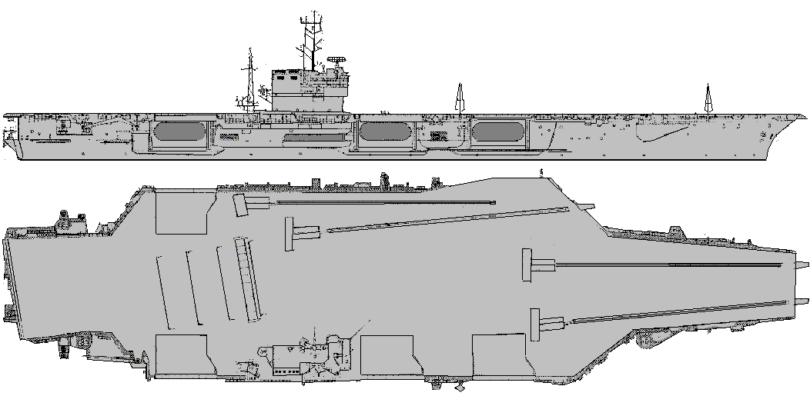
 | System | SAF  HIT | RG | LR  ADF | ADF | CAD | PDF
1 | SEASPARROW | 2AB/ 5 | 12 | - | - | 2 | 4
2 | SW RADAR | +6 |  | - | - | - | -
3 | PHALANX | - | - | - | - | - | 5
4 | ECM. | - | - | - | - | - | 5
5 | AW. Radar | +6 |  | - | - | - | -
5 | PHALANX | - | - | - | - | - | 5
6 | SEASPARROW | 2AB/ 5 | 12 | - | - | 2 | 4

33 knots | 25 knots | 15 knots | 10 knots | 5 knots | sunk

USS JOHN F. KENNEDY. CV-67 35 CV

NOISE +5
AIRCRAFT AND HELICOPTERS.
SEAKING HELICOPTERS | 1 | 2 | 3 | 4 |  |  | 5 |  |  |  | AD 3 ECM 1 |  |  |  |  |  |  |  |  |  |  |  | 4 x ASW Torpedoes. Or 4 Depth Charges.
F-14A TOMCAT | 1 | 2 | 3 | 4 |  |  | 5 |  | 6 |  | 7 |  | 8 |  | 9 |  | 10 |  | 11 |  | 12 |  | AD8/4  EW 2 | Fighter.
F-14A TOMCAT | 1 | 2 | 3 | 4 |  |  | 5 |  | 6 |  | 7 |  | 8 |  | 9 |  | 10 |  | 11 |  | 12 |  | AD8/4  EW 2
A-6E | 1 | 2 | 3 | 4 |  |  | 5 |  | 6 |  | 7 |  | 8 |  | 9 |  | 10 |  |  |  |  |  | AD 4/2  EW 2 | 8 x 250kg bombs. 5 x 750kg bombs. 4 Harpoon etc.
A-6E | 1 | 2 | 3 | 4 |  |  | 5 |  | 6 |  | 7 |  | 8 |  | 9 |  | 10 |  |  |  |  |  | AD 4/2  EW 2
S-3 VIKING | 1 | 2 | 3 | 4 |  |  | 5 |  | 6 |  | 7 |  | 8 |  | 9 |  | 10 |  |  |  |  |  | AD2/1  EW 2 | 4 ASW Torps. Or 2 Harpoon, or 6 x 750kg LGB.
KA-6D | 1 | 2 | 3 | 4 |  |  |  |  |  |  |  |  |  |  |  |  |  |  |  |  |  |  | AD 4/1  ECM - | IN FLIGHT TANKER.
EA6B PROWLER | 1 | 2 | 3 | 4 |  |  |  |  |  |  |  |  |  |  |  |  |  |  |  |  |  |  | AD4  EW 6 | 4 to 6 HARM.
E2C HAWKEYE | 1 | 2 | 3 | 4 |  |  |  |  |  |  |  |  |  |  |  |  |  |  |  |  |  |  | AD 1  ECM 2 | AIRBORNE EARLY WARNING
Moves MAA | 1 | 2 | 3 |  | 4 | 5 |  | 6 |  | 7 |  | 8 |  | 9 |  | 10 |  | 11 |  | 12 |  | MTF -2

FIRE | FLOODING | HELM | ELECTRIC SYSTEM. | HANGAR | FWD  FLIGHT  DECK | AFT  FLIGHT  DECK | ANGLED  DECK | LIFT  1 | LIFT  2 | LIFT  3 | LIFT  4
 |  |  |  | HANGAR

TOWED ASW

DECOYS. -3

USS ENTERPRISE. CV-65 40 CV
 | System | SAF  HIT | RNG | LR  ADF | ADF | CAD | PDF
1 | SEASPARROW | 2AB/ 5 | 12 | - | - | 2 | 4
2 | SW RADAR | +6 | - | - | - | -
3 | PHALANX | - | - | - | - | - | 5
4 | ECM. | - | - | - | - | - | 5
5 | AW. Radar | +6 | - | - | - | -
6 | SEASPARROW | 2AB/ 5 | 12 | - | - | 2 | 4

TOWED ASW
DECOYS. -3
NOISE +5
AIRCRAFT AND HELICOPTERS.
SEAKING HELICOPTERS | 1 | 2 |  | 3 |  | 4 |  | 5 |  | 6 |  | 7 |  | 8 |  |  |  |  |  | AD 3 ECM 1 |  | 4 x ASW Torpedoes. Or 4 Depth Charges
F-14A TOMCAT | 1 | 2 |  | 3 |  | 4 |  | 5 |  | 6 |  | 7 |  | 8 |  |  | 9 |  | 10 | AD 8/4 EW 2 |  |  | Fighter.
F-14A TOMCAT | 1 | 2 |  | 3 |  | 4 |  | 5 |  | 6 |  | 7 |  | 8 |  |  | 9 |  | 10 |  |  |  | Fighter.
A-6E | 1 | 2 |  | 3 |  | 4 |  | 5 |  | 6 |  | 7 |  | 8 |  |  | 9 |  | 10 | AD 4/2 EW 2 |  |  | 8 x 250kg bombs. 5 x 750kg bombs. 4 Harpoon etc.
A-6E | 1 | 2 |  | 3 |  | 4 |  | 5 |  | 6 |  | 7 |  | 8 |  |  | 9 |  | 10 |  |  |  | 8 x 250kg bombs. 5 x 750kg bombs. 4 Harpoon etc.
FA-18 HORNET | 1 | 2 |  | 3 |  | 4 |  | 5 |  | 6 |  | 7 |  | 8 |  |  | 9 |  |  | AD 9/4 EW 3 |  |  | 6 x 250kg bombs. Or 2 Harm, or 2 x Harpoon. Or 2 Maverick.
FA-18 HORNET | 1 | 2 |  | 3 |  | 4 |  | 5 |  | 6 |  | 7 |  | 8 |  |  | 9 |  |  |  |  |  | 6 x 250kg bombs. Or 2 Harm, or 2 x Harpoon. Or 2 Maverick.
EA6B PROWLER | 1 | 2 |  | 3 |  | 4 |  | 5 |  |  |  |  |  |  |  |  |  |  |  | AD4 EW 6 |  |  | 4 to 6 HARM.
E2C HAWKEYE | 1 | 2 |  | 3 |  | 4 |  |  |  |  |  |  |  |  |  |  |  |  |  | AD 1 ECM 2 |  |  | AIRBORNE EARLY WARNING
S-3 VIKING | 1 | 2 |  | 3 |  | 4 |  | 5 |  | 6 |  | 7 |  | 8 |  |  | 9 |  | 10 | AD 2/1 EW 2 |  |  | 4 ASW Torps. Or 2 Harpoon, or 6 x 750kg LGB.
Moves Missile AA |  |  | 1 |  | 2 |  | 3 |  | 4 |  | 5 |  | 6 |  | 7 | 8 |  | MTF= -2

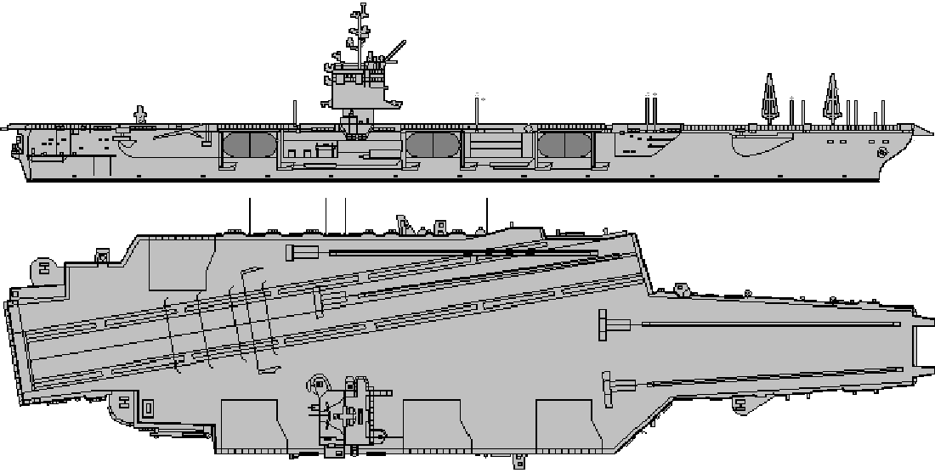
35 knots | 25 knots | 15 knots | 10 knots | 5 knots | sunk

FIRE | FLOODING | HELM | ELECTRIC SYSTEM. | HANGAR | FWD  FLIGHT  DECK | AFT  FLIGHT  DECK | ANGLED  DECK | LIFT  1 | LIFT  2 | LIFT  3 | LIFT  4
 |  |  |  | HANGAR

USS KITTYHAWK . CV-63 35 CV
 | System | SAF  HIT | RNG | LR  ADF | ADF | CAD | PDF
1 | SEASPARROW | 2AB/ 5 | 12 | - | - | 2 | 4
2 | SW RADAR | +6 | - | - | - | -
3 | PHALANX | - | - | - | - | - | 5
4 | ECM. | - | - | - | - | - | 5
5 | AW. Radar | +6 | - | - | - | -
5 | SEASPARROW | 2AB/ 5 | 12 | - | - | 2 | 4
6 | PHALANX | - | - | - | - | - | 5

AIRCRAFT AND HELICOPTERS.
SEAKING HELICOPTERS | 1 | 2 |  | 3 |  | 4 |  | 5 |  | 6 |  | 7 |  | 8 |  |  |  |  |  |  |  |  |  |  | AD 3 ECM 1 | 4 x ASW Torpedoes. Or 4 Depth Charges
F-14A TOMCAT | 1 | 2 |  | 3 |  | 4 |  | 5 |  | 6 |  | 7 |  | 8 |  |  | 9 |  | 10 |  |  |  |  |  | AD 8/4 EW 2 | Fighter.
F-14A TOMCAT | 1 | 2 |  | 3 |  | 4 |  | 5 |  | 6 |  | 7 |  | 8 |  |  | 9 |  | 10 |  |  |  |  |  | AD 8/4 EW 2
A-6E | 1 | 2 |  | 3 |  | 4 |  | 5 |  | 6 |  | 7 |  | 8 |  |  | 9 |  | 10 |  | 11 |  | 12 |  | AD 4/2 EW 2 | 8 x 250kg bombs. 5 x 750kg bombs. 4 Harpoon etc.
A-6E | 1 | 2 |  | 3 |  | 4 |  | 5 |  | 6 |  | 7 |  | 8 |  |  | 9 |  | 10 |  | 11 |  | 12 |  | AD 4/2 EW 2
FA-18 HORNET | 1 | 2 |  | 3 |  | 4 |  | 5 |  | 6 |  | 7 |  | 8 |  |  | 9 |  |  |  |  |  |  |  | AD 9/4 EW 3 | 6 x 250kg bombs. Or 2 Harm, or 2 x Harpoon. Or 2 Maverick.
FA-18 HORNET | 1 | 2 |  | 3 |  | 4 |  | 5 |  | 6 |  | 7 |  | 8 |  |  | 9 |  |  |  |  |  |  |  | AD 9/4 EW 3
EA6B PROWLER | 1 | 2 |  | 3 |  | 4 |  | 5 |  |  |  |  |  |  |  |  |  |  |  |  |  |  |  |  | AD4 EW 6 | 4 to 6 HARM.
E2C HAWKEYE | 1 | 2 |  | 3 |  | 4 |  |  |  |  |  |  |  |  |  |  |  |  |  |  |  |  |  |  | AD 1 ECM 2 | AIRBORNE EARLY WARNING
S-3 VIKING | 1 | 2 |  | 3 |  | 4 |  | 5 |  | 6 |  | 7 |  | 8 |  |  | 9 |  | 10 |  |  |  |  |  | AD 2/1 EW 2 | 4 ASW Torps. Or 2 Harpoon, or 6 x 750kg LGB.
Moves MAA |  |  | 1 |  | 2 |  | 3 |  | 4 |  | 5 |  | 6 |  | 7 | 8 |  |  |  |  |  | MTF= -2

TOWED ASW
DECOYS. -3
NOISE +5

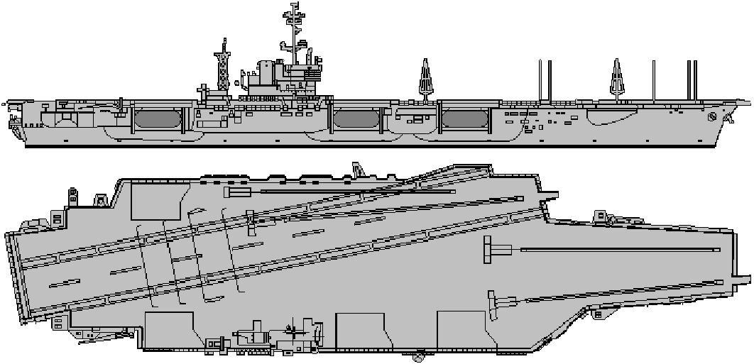
33 knots | 25 knots | 15 knots | 10 knots | 5 knots | sunk

FIRE | FLOODING | HELM | ELECTRIC SYSTEM. | HANGAR | FWD  FLIGHT  DECK | AFT  FLIGHT  DECK | ANGLED  DECK | LIFT  1 | LIFT  2 | LIFT  3 | LIFT  4
 |  |  |  | HANGAR

USS AMERICA . CV-66 35 CV
 | System | SAF  HIT | RNG | LR  ADF | ADF | CAD | PDF
1 | SEASPARROW | 2AB/ 5 | 12 | - | - | 2 | 4
2 | SW RADAR | +6 | - | - | - | -
3 | PHALANX | - | - | - | - | - | 5
4 | ECM. | - | - | - | - | - | 5
5 | AW. Radar | +6 | - | - | - | -
5 | SEASPARROW | 2AB/ 5 | 12 | - | - | 2 | 4
6 | PHALANX | - | - | - | - | - | 5

TOWED ASW
DECOYS. -3
NOISE +5
AIRCRAFT AND HELICOPTERS.
SEAKING HELICOPTERS | 1 | 2 | 3 |  |  | 4 |  | 5 |  | 6 |  |  |  |  |  |  |  |  |  |  |  |  |  |  | AD 3 ECM 1 | 4 x ASW Torpedoes. Or 4 Depth Charges
F-14A TOMCAT | 1 | 2 | 3 |  |  | 4 |  | 5 |  | 6 |  | 7 |  | 8 |  | 9 |  | 10 |  |  |  |  |  |  | AD 8/4 EW 2 | Fighter.
F-14A TOMCAT | 1 | 2 | 3 |  |  | 4 |  | 5 |  | 6 |  | 7 |  | 8 |  | 9 |  | 10 |  |  |  |  |  |  | AD 8/4 EW 2
A-6E | 1 | 2 | 3 |  |  | 4 |  | 5 |  | 6 |  | 7 |  | 8 |  | 9 |  | 10 |  |  |  |  |  |  | AD 4/2 EW 2 | 8 x 250kg bombs. 5 x 750kg bombs. 4 Harpoon etc.
A-6E | 1 | 2 | 3 |  |  | 4 |  | 5 |  | 6 |  | 7 |  | 8 |  | 9 |  | 10 |  |  |  |  |  |  | AD 4/2 EW 2
FA-18 HORNET | 1 | 2 | 3 |  |  | 4 |  | 5 |  | 6 |  | 7 |  | 8 |  | 9 |  | 10 |  |  |  |  |  |  | AD 9/4 EW 3 | 6 x 250kg bombs. Or 2 Harm, or 2 x Harpoon. Or 2 Maverick.
FA-18 HORNET | 1 | 2 | 3 |  |  | 4 |  | 5 |  | 6 |  | 7 |  | 8 |  | 9 |  | 10 |  |  |  |  |  |  | AD 9/4 EW 3
EA6B PROWLER | 1 | 2 | 3 |  |  | 4 |  | 5 |  |  |  |  |  |  |  |  |  |  |  |  |  |  |  |  | AD4 EW 6 | 4 to 6 HARM.
E2C HAWKEYE | 1 | 2 | 3 |  |  | 4 |  |  |  |  |  |  |  |  |  |  |  |  |  |  |  |  |  |  | AD 1 ECM 2 | AIRBORNE EARLY WARNING
S-3 VIKING | 1 | 2 | 3 |  |  | 4 |  | 5 |  | 6 |  | 7 |  | 8 |  | 9 |  | 10 |  |  |  |  |  |  | AD 2/1 EW 2 | 4 ASW Torps. Or 2 Harpoon, or 6 x 750kg LGB.
Moves MAA |  |  |  | 1 | 2 |  | 3 |  | 4 |  | 5 |  | 6 |  | 7 |  | 8 |  |  |  |  |  | MTF= -2

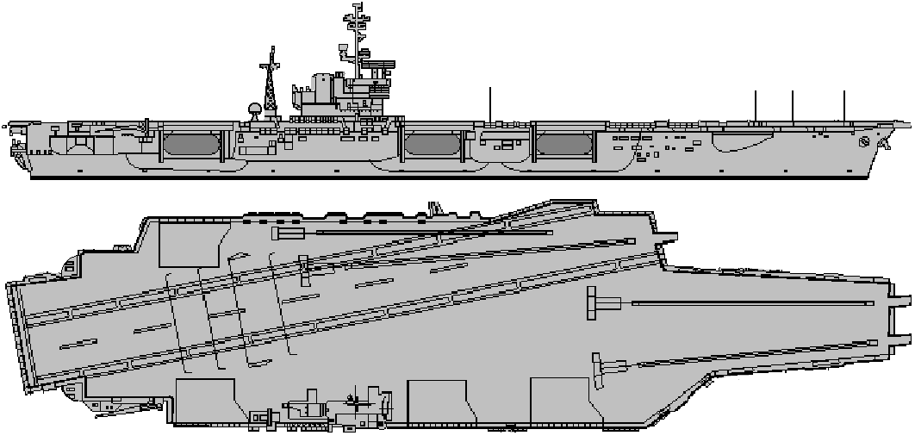
33 knots | 25 knots | 15 knots | 10 knots | 5 knots | sunk

FIRE | FLOODING | HELM | ELECTRIC SYSTEM. | HANGAR | FWD  FLIGHT  DECK | AFT  FLIGHT  DECK | ANGLED  DECK | LIFT  1 | LIFT  2 | LIFT  3 | LIFT  4
 |  |  |  | HANGAR

USS SARATOGA . CV-60 35 CV
 | System | SAF  HIT | RNG | LR  ADF | ADF | CAD | PDF
1 | SEASPARROW | 2AB/ 5 | 12 | - | - | 2 | 4
2 | SW RADAR | +6 | - | - | - | -
3 | PHALANX | - | - | - | - | - | 5
4 | ECM. | - | - | - | - | - | 5
5 | AW. Radar | +6 | - | - | - | -
5 | SEASPARROW | 2AB/ 5 | 12 | - | - | 2 | 4
6 | PHALANX | - | - | - | - | - | 5

TOWED ASW
DECOYS. -3
NOISE +5
AIRCRAFT AND HELICOPTERS.
SEAKING HELICOPTERS | 1 | 2 | 3 |  |  | 4 |  | 5 |  | 6 |  |  |  |  |  |  |  |  |  |  |  |  |  |  | AD 3 ECM 1 |  | 4 x ASW Torpedoes. Or 4 Depth Charges
F-14A TOMCAT | 1 | 2 | 3 |  |  | 4 |  | 5 |  | 6 |  | 7 |  | 8 |  | 9 |  | 10 |  |  |  |  |  |  | AD 8/4 EW 2 |  | Fighter.
F-14A TOMCAT | 1 | 2 | 3 |  |  | 4 |  | 5 |  | 6 |  | 7 |  | 8 |  | 9 |  | 10 |  |  |  |  |  |  |  |  | Fighter.
A-6E | 1 | 2 | 3 |  |  | 4 |  | 5 |  | 6 |  | 7 |  | 8 |  | 9 |  | 10 |  |  |  |  |  |  | AD 4/2 EW 2 |  | 8 x 250kg bombs. 5 x 750kg bombs. 4 Harpoon etc.
A-6E | 1 | 2 | 3 |  |  | 4 |  | 5 |  | 6 |  | 7 |  | 8 |  | 9 |  | 10 |  |  |  |  |  |  |  |  | 8 x 250kg bombs. 5 x 750kg bombs. 4 Harpoon etc.
FA-18 HORNET | 1 | 2 | 3 |  |  | 4 |  | 5 |  | 6 |  | 7 |  | 8 |  | 9 |  | 10 |  |  |  |  |  |  | AD 9/4 EW 3 |  | 6 x 250kg bombs. Or 2 Harm, or 2 x Harpoon. Or 2 Maverick.
FA-18 HORNET | 1 | 2 | 3 |  |  | 4 |  | 5 |  | 6 |  | 7 |  | 8 |  | 9 |  | 10 |  |  |  |  |  |  |  |  | 6 x 250kg bombs. Or 2 Harm, or 2 x Harpoon. Or 2 Maverick.
EA6B PROWLER | 1 | 2 | 3 |  |  | 4 |  | 5 |  |  |  |  |  |  |  |  |  |  |  |  |  |  |  |  | AD4 EW 6 |  | 4 to 6 HARM.
E2C HAWKEYE | 1 | 2 | 3 |  |  | 4 |  |  |  |  |  |  |  |  |  |  |  |  |  |  |  |  |  |  | AD 1 ECM 2 |  | AIRBORNE EARLY WARNING
S-3 VIKING | 1 | 2 | 3 |  |  | 4 |  | 5 |  | 6 |  | 7 |  | 8 |  | 9 |  | 10 |  |  |  |  |  |  | AD 2/1 EW 2 |  | 4 ASW Torps. Or 2 Harpoon, or 6 x 750kg LGB.
Moves MAA |  |  |  | 1 | 2 |  | 3 |  | 4 |  | 5 |  | 6 |  | 7 |  | 8 |  |  |  |  |  | MTF= -2

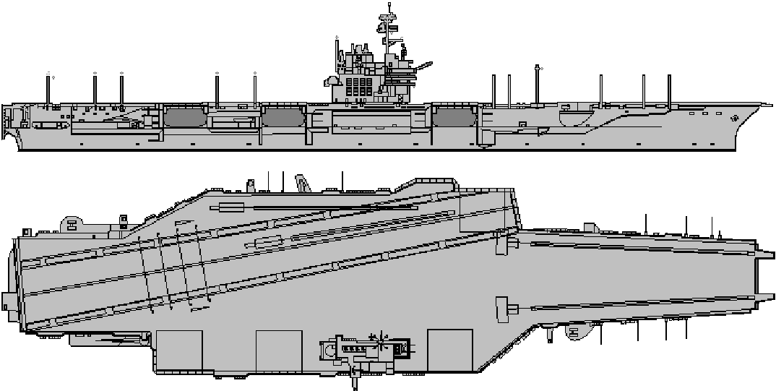
32 knots | 25 knots | 15 knots | 10 knots | 5 knots | sunk

FIRE | FLOODING | HELM | ELECTRIC SYSTEM. | HANGAR | FWD  FLIGHT  DECK | AFT  FLIGHT  DECK | ANGLED  DECK | LIFT  1 | LIFT  2 | LIFT  3 | LIFT  4
 |  |  |  | HANGAR

USS MIDWAY . CV-41 30 CV

 | System | SAF  HIT | RNG | LR  ADF | ADF | CAD | PDF
1 | SW RADAR | +4 | - | - | - | -
2 | PHALANX | - | - | - | - | - | 4
3 | ECM. | - | - | - | - | - | 4
4 | AW. Radar | +5 | - | - | - | -
5-6 | SEASPARROW 7D | 2AB/ 4 | 9 | - | - | 1 | 4

TOWED ASW
DECOY. -2
NOISE +5
AIRCRAFT AND HELICOPTERS.
SEAKING HELICOPTERS | 1 | 2 | 3 |  |  | 4 |  | 5 |  | 6 |  |  |  |  |  |  |  |  |  |  |  |  |  |  | AD 3 ECM 1 | 4 x ASW Torpedoes. Or 4 Depth Charges
A-6E | 1 | 2 | 3 |  |  | 4 |  | 5 |  | 6 |  | 7 |  | 8 |  | 9 |  | 10 |  | 11 |  | 12 |  |  | AD 4/2 EW 2 | 8 x 250kg bombs. 5 x 750kg bombs. 4 Harpoon etc.
FA-18 HORNET | 1 | 2 | 3 |  |  | 4 |  | 5 |  | 6 |  | 7 |  | 8 |  | 9 |  | 10 |  | 11 |  | 12 |  |  | AD 9/4 EW 3 | 6 x 250kg bombs. Or 2 Harm, or 2 x Harpoon. Or 2 Maverick.
FA-18 HORNET | 1 | 2 | 3 |  |  | 4 |  | 5 |  | 6 |  | 7 |  | 8 |  | 9 |  | 10 |  | 11 |  | 12 |  |  | AD 9/4 EW 3
FA-18 HORNET | 1 | 2 | 3 |  |  | 4 |  | 5 |  | 6 |  | 7 |  | 8 |  | 9 |  | 10 |  | 11 |  | 12 |  |  | AD 9/4 EW 3
E2C HAWKEYE | 1 | 2 | 3 |  |  | 4 |  |  |  |  |  |  |  |  |  |  |  |  |  |  |  |  |  |  | AD 1 ECM 2 | AIRBORNE EARLY WARNING
EA6B PROWLER | 1 | 2 | 3 |  |  | 4 |  |  |  |  |  |  |  |  |  |  |  |  |  |  |  |  |  |  | AD4 EW 6 | 4 to 6 HARM.
Moves MAA |  |  |  | 1 | 2 |  | 3 |  | 4 |  | 5 |  | 6 |  | 7 |  | 8 |  |  |  |  |  | MTF= -2

FIRE | FLOODING | HELM | ELECTRIC SYSTEM. | HANGAR | FWD  FLIGHT  DECK | AFT  FLIGHT  DECK | ANGLED  DECK | LIFT  1 | LIFT  2 | LIFT  3

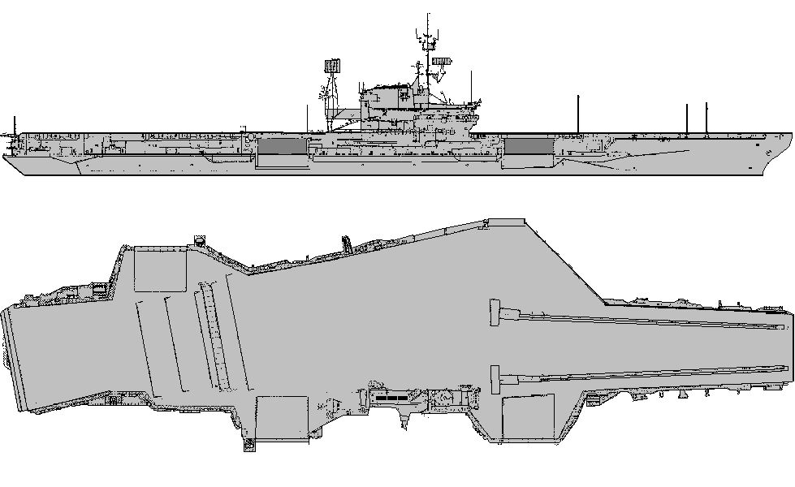
30 knots | 25 knots | 15 knots | 10 knots | 5 knots | sunk

USS CORAL SEA . CV-43 30 CV
 | System | SAF  HIT | RNG | LR  ADF | ADF | CAD | PDF
1 | SW RADAR | +4 | - | - | - | -
2-3 | ECM. | - | - | - | - | - | 4
4 | AW. Radar | +5 | - | - | - | -
5 | PHALANX | - | - | - | - | - | 4
6 | PHALANX | - | - | - | - | - | 4

NO TOWED ASW
DECOY.

NOISE + 5
AIRCRAFT AND HELICOPTERS.
SEAKING HELICOPTERS | 1 | 2 | 3 | 4 | 5 | 6 | 7 |  |  |  |  |  |  | AD 3 ECM 1 | 4 x ASW Torpedoes. Or 4 Depth Charges
A-6E | 1 | 2 | 3 | 4 | 5 | 6 | 7 | 8 | 9 | 10 | 11 | 12 |  | AD 4/2 EW 2 | 8 x 250kg bombs. 5 x 750kg bombs. 4 Harpoon etc.
FA-18 HORNET | 1 | 2 | 3 | 4 | 5 | 6 | 7 | 8 | 9 | 10 | 11 | 12 |  | AD 9/4 EW 3 | 6 x 250kg bombs. Or 2 Harm, or 2 x Harpoon. Or 2 Maverick.
FA-18 HORNET | 1 | 2 | 3 | 4 | 5 | 6 | 7 | 8 | 9 | 10 | 11 | 12 |  | AD 9/4 EW 3 | 6 x 250kg bombs. Or 2 Harm, or 2 x Harpoon. Or 2 Maverick.
FA-18 HORNET | 1 | 2 | 3 | 4 | 5 | 6 | 7 | 8 | 9 | 10 | 11 | 12 |  | AD 9/4 EW 3 | 6 x 250kg bombs. Or 2 Harm, or 2 x Harpoon. Or 2 Maverick.
E2C HAWKEYE | 1 | 2 | 3 |  |  |  |  |  |  |  |  |  |  | AD 1 ECM 2 | AIRBORNE EARLY WARNING
KA6B TANKER | 1 | 2 | 3 | 4 |  |  |  |  |  |  |  |  |  | AD4 EW 0

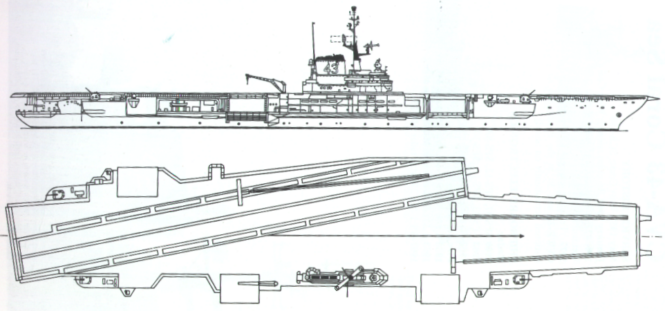
30 knots | 25 knots | 15 knots | 10 knots | 5 knots | sunk

FIRE | FLOODING | HELM | ELECTRIC SYSTEM. | HANGAR | FWD  FLIGHT  DECK | AFT  FLIGHT  DECK | ANGLED  DECK | LIFT  1 | LIFT  2 | LIFT  3

USS ORISKANY . CV-34 20 CV

 | System | SAF  HIT | RNG | LR  ADF | ADF | CAD | PDF
1 | SW RADAR | +4 | - | - | - | -
2-3 | ECM. | - | - | - | - | - | 2
4 | AW. Radar | +5 | - | - | - | - | -
5 | 5” SINGLE | 2 | 8 | - | - | 1 | -
6 | 5” SINGLE | 2 | 8 | - | - | 1 | -

1974-76
NO TOWED DECOYS
NOISE +5
AIRCRAFT AND HELICOPTERS.
SEAKING HELICOPTERS | 1 | 2 | 3 | 4 |  |  |  |  |  |  |  |  |  | AD 3 ECM 1 | 4 x ASW Torpedoes. Or 4 Depth Charges
A-6 INTRUDER | 1 | 2 | 3 | 4 | 5 | 6 | 7 | 8 |  |  |  |  |  | AD 4/2 | 8 x 250kg bombs. 5 x 750kg bombs.
F8E CRUSADER | 1 | 2 | 3 | 4 | 5 | 6 | 7 | 8 |  |  |  |  |  | AD 6 | FIGHTER
S2-TRACKER | 1 | 2 | 3 | 4 |  |  |  |  |  |  |  |  |  | AD 1 | 2 x ASW Torpedoes. Or 4 Depth Charges. Or 3 250kg bombs.
A7E Corsair II | 1 | 2 | 3 | 4 | 5 | 6 | 7 | 8 |  |  |  |  |  | AD 5/2 | 8 x 500kg bombs, or 18 x 250kg bombs, or Walleye, or HARM.

FIRE | FLOODING | HELM | ELECTRIC SYSTEM. | HANGAR | FWD  FLIGHT  DECK | AFT  FLIGHT  DECK | ANGLED  DECK | LIFT  1  FWD | LIFT  2  PORT | LIFT  3  STBD

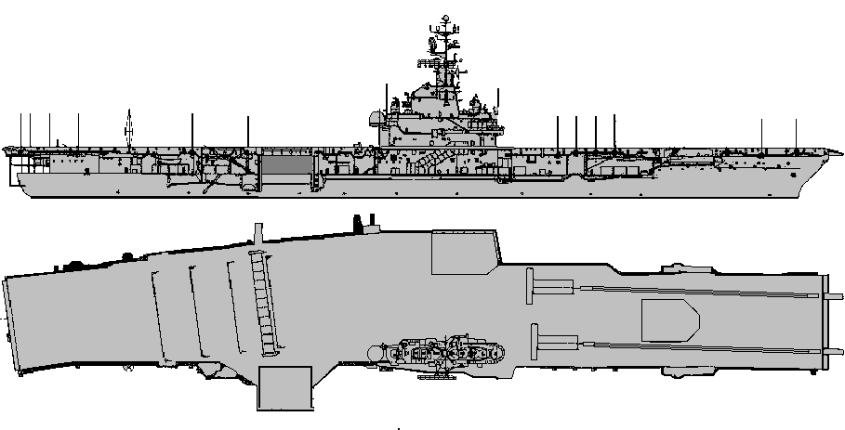
32 knots | 25 knots | 15 knots | 10 knots | 5 knots | sunk

TARAWA LHA 1 17 SDF
 | System | SAF | RNG | LR ADF | ADF | CAD | PDF
1 | SEASPARROW | 2AB/ 5 | 12 | - | 2 | 2 | 4
2 | SW RADAR | +6 | - | - | - | -
3 | PHALANX | - | - | - | - | - | 5
4 | ECM. | - | - | - | - | - | 6
5 | AW. Radar | +6 | - | - | - | -
6 | 5” Mk 45 | 4 | 13 | - | - | 3 | 1

AIRCRAFT AND HELICOPTERS.
SEAKING HELICOPTERS |  | 1 |  |  | 2 |  |  |  |  |  |  |  |  |  |  |  |  |  |  |  |  | AD 2  EW 1 |  | 4 x ASW Torpedoes. Or 4 Depth Charges
CH-46 SEAKNIGHT |  | 1 |  |  | 2 |  | 3 |  | 4 |  | 5 |  | 6 |  | 7 |  | 8 |  | 9 |  |  | AD 1 |  | TRANSPORT.
 |  | 1 |  |  | 2 |  | 3 |  | 4 |  | 5 |  | 6 |  | 7 |  | 8 |  | 9 |  |  |  |  | TRANSPORT.
CH-65 SEASTALLION |  | 1 |  |  | 2 |  | 3 |  | 4 |  |  |  |  |  |  |  |  |  |  |  |  | AD 1 |  | TRANSPORT.
RH=65 SEA DRAGON. |  | 1 |  |  | 2 |  | 3 |  | 4 |  |  |  |  |  |  |  |  |  |  |  |  | AD 1 |  | MINESWEEPER.
Moves MAA | 1 |  | 2 | 3 |  | 4 |  | 5 |  | 6 |  | 7 |  | 8 |  |  |  |  |  | MTF= -2

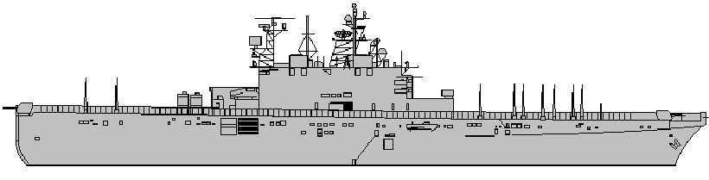
24 knots | 15 knots | 12 knots | 10 knots | 5 knots | sunk

NOISE +3
TOWED ASW DECOY 3
Carries 6
LCM6
1 x LCAC.
CAN LAUNCH 12 HELICOPTERS ATONCE.
NOISE +3
 | System | SAF  HIT | RNG | LR  ADF | ADF | CAD | PDF
1 | SEASPARROW | 2AB/ 5 | 12 | - | 2 | 2 | 4
2 | SW RADAR | +6 | - | - | - | -
3 | PHALANX | - | - | - | - | - | 5
4 | ECM. | - | - | - | - | - | 6
5 | AW. Radar | +6 | - | - | - | -
6 | 5” Mk 45 | 4 | 13 | - | - | 3 | 1

FIRE | FLOODING | HELM | ELECTRIC SYSTEM. | HANGAR | FWD  FLIGHT  DECK | AFT  FLIGHT  DECK | LIFT  1 | LIFT  2

AIRCRAFT AND HELICOPTERS.
SEAKING HELICOPTERS |  | 1 |  |  | 2 |  |  |  |  |  |  |  |  |  |  |  |  |  |  |  |  | AD 2  EW 1 |  | 4 x ASW Torpedoes. Or 4 Depth Charges
CH-46 SEAKNIGHT |  | 1 |  |  | 2 |  | 3 |  | 4 |  | 5 |  | 6 |  | 7 |  | 8 |  | 9 |  |  | AD 1 |  | TRANSPORT.
 |  | 1 |  |  | 2 |  | 3 |  | 4 |  | 5 |  | 6 |  | 7 |  | 8 |  | 9 |  |  |  |  | TRANSPORT.
CH-65 SEASTALLION |  | 1 |  |  | 2 |  | 3 |  | 4 |  |  |  |  |  |  |  |  |  |  |  |  | AD 1 |  | TRANSPORT.
RH=65 SEA DRAGON. |  | 1 |  |  | 2 |  | 3 |  | 4 |  |  |  |  |  |  |  |  |  |  |  |  | AD 1 |  | MINESWEEPER.
Moves MAA | 1 |  | 2 | 3 |  | 4 |  | 5 |  | 6 |  | 7 |  | 8 |  |  |  |  |  | MTF= -2

CAN LAUNCH 12 HELICOPTERS ATONCE.
SAIPAN LHA 2 17 SDF
FIRE | FLOODING | HELM | ELECTRIC SYSTEM. | HANGAR | FWD  FLIGHT  DECK | AFT  FLIGHT  DECK | LIFT  1 | LIFT  2

Carries 6
LCM6
1 x LCAC.

24 knots | 15 knots | 12 knots | 10 knots | 5 knots | sunk

WASP LHD 1 20 SDF
 | System | SAF  HIT | RNG | LR  ADF | ADF | CAD | PDF
1 | SEASPARROW | 2AB/ 5 | 12 | - | 2 | 2 | 4
2 | SW RADAR | +6 | - | - | - | -
3 | PHALANX | - | - | - | - | - | 5
4 | ECM. | - | - | - | - | - | 5
5 | AW. Radar | +6 | - | - | - | -
5 | SEASPARROW | 2AB/ 5 | 12 | - | 2 | 2 | 4
6 | PHALANX | - | - | - | - | - | 5

TOWED ASW DECOY 3
Carries 2 x LCM6
1 x LCAC.

SEA GNAT ANTI TORPEDO SYSTEM.
60% TO HIT.
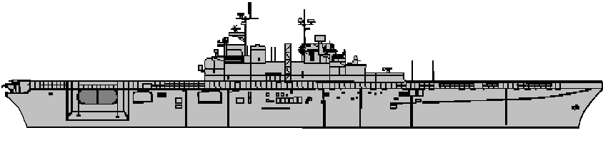
23 knots | 15 knots | 12 knots | 10 knots | 5 knots | sunk

AIRCRAFT AND HELICOPTERS.
AV-8B MARINE HARRIER |  | 1 |  |  | 2 |  | 3 |  | 4 |  | 5 |  | 6 |  | 7 |  | 8 |  | 9 |  |  | 8/3  EW 2 |  | 4 x AGM-65 or 8 x 250 kg bombs
CH-46 SEAKNIGHT |  | 1 |  |  | 2 |  | 3 |  | 4 |  | 5 |  | 6 |  | 7 |  | 8 |  | 9 |  | 10 | AD 1 |  | TRANSPORT.
 |  | 1 |  |  | 2 |  | 3 |  | 4 |  | 5 |  | 6 |  | 7 |  | 8 |  | 9 |  | 10 |  |  | TRANSPORT.
CH-65 SEASTALLION |  | 1 |  |  | 2 |  | 3 |  | 4 |  | 5 |  | 6 |  | 7 |  | 8 |  | 9 |  | 10 | AD 1 |  | TRANSPORT.
Moves MAA | 1 |  | 2 | 3 |  | 4 |  | 5 |  | 6 |  | 7 |  | 8 |  |  |  |  |  | MTF= -2

NOISE +3
CAN LAUNCH
12 HELICOPTERS AT ONCE.
FIRE | FLOODING | HELM | ELECTRIC SYSTEM. | HANGAR | FWD  FLIGHT  DECK | AFT  FLIGHT  DECK | LIFT  1 | LIFT  2

ESSEX LHD 2 20 SDF 20 LHA
 | System | SAF  HIT | RNG | LR  ADF | ADF | CAD | PDF
1 | SEASPARROW | 2AB/ 5 | 12 | - | 2 | 2 | 4
2 | SW RADAR | +6 | - | - | - | -
3 | PHALANX | - | - | - | - | - | 5
4 | ECM. | - | - | - | - | - | 5
5 | AW. Radar | +6 | - | - | - | -
5 | SEASPARROW | 2AB/ 5 | 12 | - | 2 | 2 | 4
6 | PHALANX | - | - | - | - | - | 5

AIRCRAFT AND HELICOPTERS.
AV-8B MARINE HARRIER |  | 1 |  |  | 2 |  | 3 |  | 4 |  | 5 |  | 6 |  | 7 |  | 8 |  | 9 |  |  | 8/3  EW 2 |  | 4 x AGM-65 or 8 x 250 kg bombs
CH-46 SEAKNIGHT |  | 1 |  |  | 2 |  | 3 |  | 4 |  | 5 |  | 6 |  | 7 |  | 8 |  | 9 |  | 10 | AD 1 |  | TRANSPORT.
 |  | 1 |  |  | 2 |  | 3 |  | 4 |  | 5 |  | 6 |  | 7 |  | 8 |  | 9 |  | 10 |  |  | TRANSPORT.
CH-65 SEASTALLION |  | 1 |  |  | 2 |  | 3 |  | 4 |  | 5 |  | 6 |  | 7 |  | 8 |  | 9 |  | 10 | AD 1 |  | TRANSPORT.
Moves MAA | 1 |  | 2 | 3 |  | 4 |  | 5 |  | 6 |  | 7 |  | 8 |  |  |  |  |  | MTF= -2

TOWED ASW DECOY 3
SEA GNAT ANTI TORPEDO SYSTEM.
60% TO HIT.
FIRE | FLOODING | HELM | ELECTRIC SYSTEM. | HANGAR | FWD  FLIGHT  DECK | AFT  FLIGHT  DECK | LIFT  1 | LIFT  2

23 knots | 15 knots | 12 knots | 10 knots | 5 knots | sunk

NOISE +3
CAN LAUNCH
12 HELICOPTERS AT ONCE
Carries 2 x LCM6
1 x LCAC.
IWO JIMA LPH 2 10 SDF
AIRCRAFT AND HELICOPTERS.
CH-46 SEAKNIGHT |  | 1 |  |  | 2 |  | 3 |  | 4 |  | 5 |  | 6 |  | 7 |  | 8 |  |  |  |  | AD 1 |  | TRANSPORT.
 |  | 1 |  |  | 2 |  | 3 |  | 4 |  | 5 |  | 6 |  | 7 |  | 8 |  |  |  |  |  |  | TRANSPORT.
CH-65 SEASTALLION |  | 1 |  |  | 2 |  | 3 |  | 4 |  |  |  |  |  |  |  |  |  |  |  |  | AD 1 |  | TRANSPORT.
Moves MAA | 1 |  | 2 | 3 |  | 4 |  | 5 |  | 6 |  | 7 |  | 8 |  |  |  |  |  | MTF= -2

TOWED ASW DECOY 3
 | System | SAF  HIT | RNG | LR  ADF | ADF | CAD | PDF
1 | SEASPARROW | 2AB/ 4 | 9 | - | - | 1 | 4
2 | SW RADAR | +6 | - | - | - | -
2 | PHALANX | - | - | - | - | - | 5
3 | ECM. | - | - | - | - | - | 5
4 | AW. Radar | +6 | - | - | - | -
4 | SEASPARROW | 2AB/ 4 | 9 | - | - | 1 | 4
5 | PHALANX | - | - | - | - | - | 5
6 | 3” Mk33 | 2 | 2 | - | - | 2 | -

Noise 4
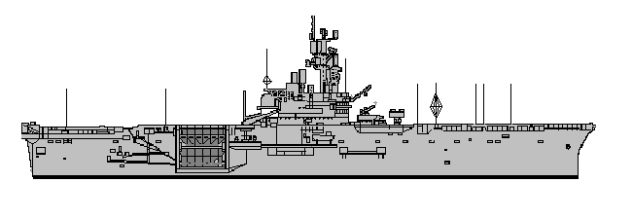
22 knots | 15 knots | 12 knots | 10 knots | 5 knots | sunk

CARRIES SEVERAL LANDING CRAFT.
TRIPOLI LPH 10 10 SDF
 | System | SAF  HIT | RNG | LR  ADF | ADF | CAD | PDF
1 | SEASPARROW | 2AB/ 4 | 9 | - | - | 1 | 4
2 | SW RADAR | +6 | - | - | - | -
2 | PHALANX | - | - | - | - | - | 5
3 | ECM. | - | - | - | - | - | 5
4 | AW. Radar | +6 | - | - | - | -
4 | SEASPARROW | 2AB/ 4 | 9 | - | - | 1 | 4
5 | PHALANX | - | - | - | - | - | 5
6 | 3” Mk33 | 2 | 2 | - | - | 2 | -

TOWED ASW DECOY 3
Noise 4
AIRCRAFT AND HELICOPTERS.
CH-46 SEAKNIGHT |  | 1 |  |  | 2 |  | 3 |  | 4 |  | 5 |  | 6 |  | 7 |  | 8 |  |  |  |  | AD 1 |  | TRANSPORT.
 |  | 1 |  |  | 2 |  | 3 |  | 4 |  | 5 |  | 6 |  | 7 |  | 8 |  |  |  |  |  |  | TRANSPORT.
CH-65 SEASTALLION |  | 1 |  |  | 2 |  | 3 |  | 4 |  |  |  |  |  |  |  |  |  |  |  |  | AD 1 |  | TRANSPORT.
Moves MAA | 1 |  | 2 | 3 |  | 4 |  | 5 |  | 6 |  | 7 |  | 8 |  |  |  |  |  | MTF= -2

CARRIES SEVERAL LANDING CRAFT.
CAN LAUNCH
7 HELICOPTERS AT ONCE.
FIRE | FLOODING | HELM | ELECTRIC SYSTEM. | HANGAR | FWD  FLIGHT  DECK | AFT  FLIGHT  DECK | LIFT  1 | LIFT  2

CAN LAUNCH
7 HELICOPTERS AT ONCE.
FIRE | FLOODING | HELM | ELECTRIC SYSTEM. | HANGAR | FWD  FLIGHT  DECK | AFT  FLIGHT  DECK | LIFT  1 | LIFT  2

22 knots | 15 knots | 12 knots | 10 knots | 5 knots | sunk

 | System | SAF  HIT | RNG | LR  ADF | ADF | CAD | PDF
1 | SEASPARROW | 2AB/ 4 | 9 | - | - | 1 | 4
2 | SW RADAR | +6 | - | - | - | -
2 | PHALANX | - | - | - | - | - | 5
3 | ECM. | - | - | - | - | - | 5
4 | AW. Radar | +6 | - | - | - | -
4 | SEASPARROW | 2AB/ 4 | 9 | - | - | 1 | 4
5 | PHALANX | - | - | - | - | - | 5
6 | 3” Mk33 | 2 | 2 | - | - | 2 | -

NO TOWED
ASW DECOYS
AIRCRAFT AND HELICOPTERS.
CH-46 SEAKNIGHT |  | 1 |  |  | 2 |  | 3 |  | 4 |  | 5 |  | 6 |  | 7 |  | 8 |  |  |  |  | AD 1 |  | TRANSPORT.
 |  | 1 |  |  | 2 |  | 3 |  | 4 |  | 5 |  | 6 |  | 7 |  | 8 |  |  |  |  |  |  | TRANSPORT.
CH-65 SEASTALLION |  | 1 |  |  | 2 |  | 3 |  | 4 |  |  |  |  |  |  |  |  |  |  |  |  | AD 1 |  | TRANSPORT.
Moves MAA | 1 |  | 2 | 3 |  | 4 |  | 5 |  | 6 |  | 7 |  | 8 |  |  |  |  |  | MTF= -2

CARRIES SEVERAL
LANDING CRAFT.
FIRE | FLOODING | HELM | ELECTRIC SYSTEM. | HANGAR | FWD  FLIGHT  DECK | AFT  FLIGHT  DECK | LIFT  1 | LIFT  2

CAN LAUNCH
7 HELICOPTERS AT ONCE.
USS INCHON. LPH-12 10STF
22 knots | 15 knots | 12 knots | 10 knots | 5 knots | sunk

USS GUADALCANAL LPH-7 10STF
NO TOWED
ASW DECOYS
 | System | SAF  HIT | RNG | LR  ADF | ADF | CAD | PDF
1 | SEASPARROW | 2AB/ 4 | 9 | - | - | 1 | 4
2 | SW RADAR | +6 | - | - | - | -
2 | PHALANX | - | - | - | - | - | 5
3 | ECM. | - | - | - | - | - | 5
4 | AW. Radar | +6 | - | - | - | -
4 | SEASPARROW | 2AB/ 4 | 9 | - | - | 1 | 4
5 | PHALANX | - | - | - | - | - | 5
6 | 3” Mk33 | 2 | 2 | - | - | 2 | -

AV-8B HARRIER |  | 1 |  |  | 2 |  | 3 |  | 4 |  | 5 |  | 6 |  | 7 |  | 8 |  | 9 |  | 10 | AD 1 |  | VTOL Attack aircraft.
 |  | 1 |  |  | 2 |  | 3 |  | 4 |  | 5 |  | 6 |  | 7 |  | 8 |  | 9 |  | 10 |  |  | VTOL Attack aircraft.
SEAKING |  | 1 |  |  | 2 |  | 3 |  | 4 |  |  |  |  |  |  |  |  |  |  |  |  | AD 1 |  | ASW HELICOPTER
Moves MAA | 1 |  | 2 | 3 |  | 4 |  | 5 |  | 6 |  | 7 |  | 8 |  |  |  |  |  | MTF= -2

FIRE | FLOODING | HELM | ELECTRIC SYSTEM. | HANGAR | FWD  FLIGHT  DECK | AFT  FLIGHT  DECK | LIFT  1 | LIFT  2

CARRIES SEVERAL
LANDING CRAFT.

CAN LAUNCH
7 HELICOPTERS AT ONCE
22 knots | 15 knots | 12 knots | 10 knots | 5 knots | sunk

USS MISSOURI BB63 BB 27
 | System | SAF | RNG | LR  ADF | ADF | CAD | PDF | ASW
1 | 16” A | 10 | 20 | - | - | - | - | -
1 | QUAD TOMAHAWK | 35/7 | 250 | - | - | - | - | -
2 | Phalanx | - | - | - | - | - | 5 | -
2 | QUAD TOMAHAWK | 35/7 | 250 | - | - | - | - | -
3 | QUAD TOMAHAWK | 35/7 | 250 | - | - | - | - | -
3 | 16” B | 10 | 20 | - | - | - | - | -
4 | Phalanx | - | - | - | - | - | 5
4 | Quad Harpoon | 35/7 | 250 | - | - | - | - | -
5 | 5” L38 TWIN | 4 | 8 | - | - | 2 | - | -
5 | Quad Harpoon | 20/8 | 60 | - | - | - | - | -
6 | Quad Harpoon | 20/8 | 60 | - | - | - | - | -
7 | 5” L38 TWIN | 4 | 8 | - |  | 2 | - | -
8 | Quad Harpoon | 35/7 | 250 | - | - | - | - | -
8 | ECM. | - | - | - | - | - | 5 | -
9 | SW RADAR | +4 |  | - | - | - | - | -
9 | 16” Y | 10 | 20 | - | - | - | - | -
10 | AW RADAR | +4 |  | - | - | - | - | -
10 | QUAD TOMAHAWK | 35/7 | 250 | - | - | - | - | -

SEAKING HELICOPTER | 1 |  |  | AD 3 ECM 1 4 x ASW Torpedoes. Or 4 Depth Charges
HARPOON | 1 | 2 | 3 | 4 |  | 1 | 2 | 3 | 4 |  |  |  | MDF= - 3
HARPOON | 1 | 2 | 3 | 4 |  | 1 | 2 | 3 | 4 |  |  |  | MDF= - 3
TOMAHAWK ABL | 1 | 2 | 3 | 4 |  | 1 | 2 | 3 | 4 |  |  |  | MDF = -2
TOMAHAWK ABL | 1 | 2 | 3 | 4 |  | 1 | 2 | 3 | 4 |  |  |  | MDF = -2

FIRE | FLOODING | HELM | ELECTRIC SYSTEM. | HELI  DECK | HANGAR

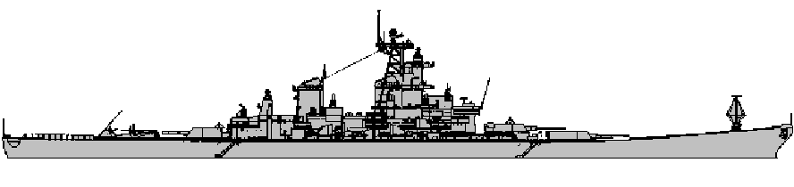

NO TOWED DECOYS.
NOISE = 5

33 knots | 25 knots | 20 knots | 15 knots | 10 knots | sunk

USS NEW JERSEY BB 62 BB 27
 | System | SAF | RNG | LR  ADF | ADF | CAD | PDF | ASW
1 | 16” A | 10 | 20 | - | - | - | - | -
1 | QUAD TOMAHAWK | 35/7 | 250 | - | - | - | - | -
2 | Phalanx | - | - | - | - | - | 5 | -
2 | QUAD TOMAHAWK | 35/7 | 250 | - | - | - | - | -
3 | QUAD TOMAHAWK | 35/7 | 250 | - | - | - | - | -
3 | 16” B | 10 | 20 | - | - | - | - | -
4 | Phalanx | - | - | - | - | - | 5
4 | Quad Harpoon | 35/7 | 250 | - | - | - | - | -
5 | 5” L38 TWIN | 4 | 8 | - | - | 2 | - | -
5 | Quad Harpoon | 20/8 | 60 | - | - | - | - | -
6 | Quad Harpoon | 20/8 | 60 | - | - | - | - | -
7 | 5” L38 TWIN | 4 | 8 | - |  | 2 | - | -
8 | Quad Harpoon | 35/7 | 250 | - | - | - | - | -
8 | ECM. | - | - | - | - | - | 5 | -
9 | SW RADAR | +4 |  | - | - | - | - | -
9 | 16” Y | 10 | 20 | - | - | - | - | -
10 | AW RADAR | +4 |  | - | - | - | - | -
10 | QUAD TOMAHAWK | 35/7 | 250 | - | - | - | - | -

SEAKING HELICOPTER | 1 |  |  | AD 3 ECM 1 4 x ASW Torpedoes. Or 4 Depth Charges
HARPOON | 1 | 2 | 3 | 4 |  | 1 | 2 | 3 | 4 |  |  |  | MDF= - 3
HARPOON | 1 | 2 | 3 | 4 |  | 1 | 2 | 3 | 4 |  |  |  | MDF= - 3
TOMAHAWK ABL | 1 | 2 | 3 | 4 |  | 1 | 2 | 3 | 4 |  |  |  | MDF = -2
TOMAHAWK ABL | 1 | 2 | 3 | 4 |  | 1 | 2 | 3 | 4 |  |  |  | MDF = -2

FIRE | FLOODING | HELM | ELECTRIC SYSTEM. | HELI  DECK | HANGAR

NOISE = 5
NO TOWED DECOYS.

33 knots | 25 knots | 20 knots | 15 knots | 10 knots | sunk

