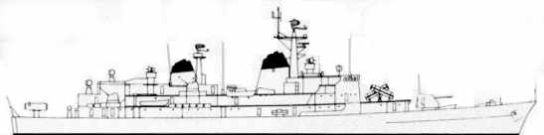
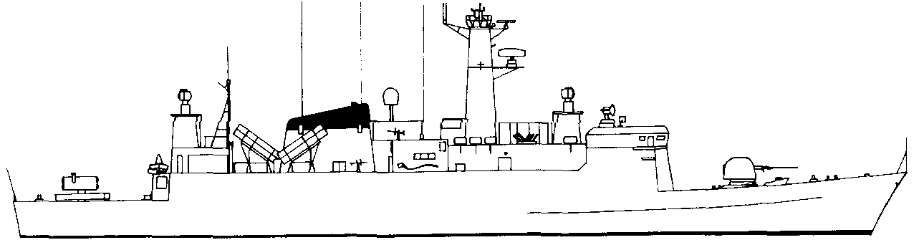
PEDER SKRAM F352. 2 STF
SystemSAFRGLADFADFCADPDFAsw15” twin 410--11-2Nato RIM7H
Seasparrow2AB12--13Hi/Vlo3Sonar+1. 4ECM-----1-20mm AA.5115Harpoon.20/860-----6ASW Torp0/105----D/77AWRadar38SW Radar3940mm AA24--11-040mm AA24--11-ASW.Port12Stbd12T61 Swedish Torp.HARPOONPort1234Stbd1234FIREFloodingHELMElectronics
30kn2520105SUNK
NOISE +1
ASW DECOY -2
NILS JUEL. F-354. 1 STF
SystemSAFRGLADFADFCADPDFAsw176mmOTO24--31Hi/VloDepth charges0/10PO----S/12Nato RIM7H
Seasparrow2AB12--13Hi/Vlo3Sonar+1. 4ECM-----2-5Harpoon.20/860-----AW Radar36SW Radar3Moves MAA123456-4 MTF.HARPOONPort1234Stbd1234FIREFloodingHELMElectronics
NOISE +1
ASW DECOY -2
PETER TORDENSKJOLD FF-356. 1 STF
SystemSAFRGLADFADFCADPDFAsw176mmOTO24--31Hi/VloDepth charges0/10PO----S/12Nato RIM7H
Seasparrow2AB12--13Hi/Vlo3Sonar+1. 4ECM-----2-5Harpoon.20/860-----AW Radar36SW Radar3Moves MAA123456-4 MTF.HARPOONPort1234Stbd1234FIREFloodingHELMElectronics
OLFERT FISCHER F-355. 1 STF
SystemSAFRGLADFADFCADPDFAsw176mmOTO24--31Hi/VloDepth charges0/10PO----S/12Nato RIM7H
Seasparrow2AB12--13Hi/Vlo3Sonar+1. 4ECM-----2-5Harpoon.20/860-----AW Radar36SW Radar3Moves MAA123456-4 MTF.HARPOONPort1234Stbd1234FIREFloodingHELMElectronics
NOISE +1
ASW DECOY -2
NOISE +1
ASW DECOY -2

 |  |  |  | 10 | 5 | SUNK


 | 30kn | 25 | 20 | 10 | 5 | SUNK

 | 30kn | 25 | 20 | 10 | 5 | SUNK

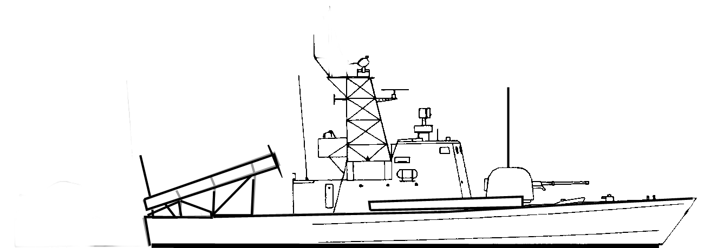
BILLE P-540. .25 STF
SystemSAFRGLADFADFCADPDFAsw176mmOTO24--31Hi/Vlo2Surface Torpedoes105-----3ECM-----3-4Harpoon.20/860-----5AW Radar36SW Radar3HARPOONPort12Stbd12MTF-3FIREFloodingHELMElectronics
No ASW decoys.
Noise. +3
HUITFELDT P-543. .25 STF
SystemSAFRGLADFADFCADPDFAsw176mmOTO24--31Hi/Vlo2Surface Torpedoes105-----3ECM-----3-4Harpoon.20/860-----5AW Radar36SW Radar3HARPOONPort12Stbd12MTF-3FIREFloodingHELMElectronics
No ASW decoys.
Noise. +3

WILLEMOES P-549. .25 STF
SystemSAFRGLADFADFCADPDFAsw176mmOTO24--31Hi/Vlo2Surface Torpedoes105-----3ECM-----3-4Harpoon.20/860-----5AW Radar36SW Radar3HARPOONPort12Stbd12MTF-3FIREFloodingHELMElectronics
No ASW decoys.
Noise. +3
HAMMER. P-542. .25 STF
SystemSAFRGLADFADFCADPDFAsw176mmOTO24--31Hi/Vlo2Surface Torpedoes105-----3ECM-----3-4Harpoon.20/860-----5AW Radar36SW Radar3HARPOONPort12Stbd12MTF-3FIREFloodingHELMElectronics
No ASW decoys.
Noise. +3

