
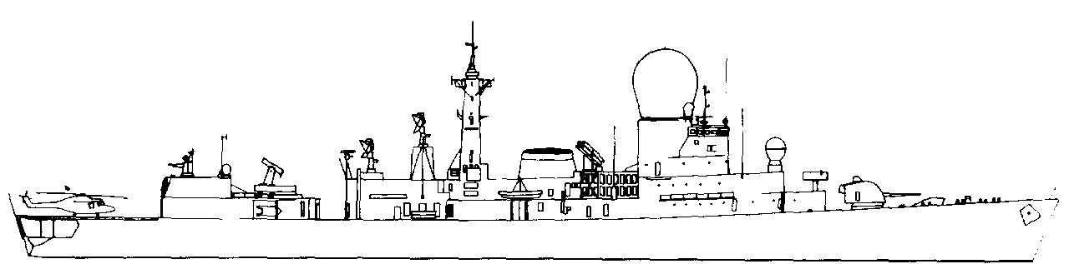
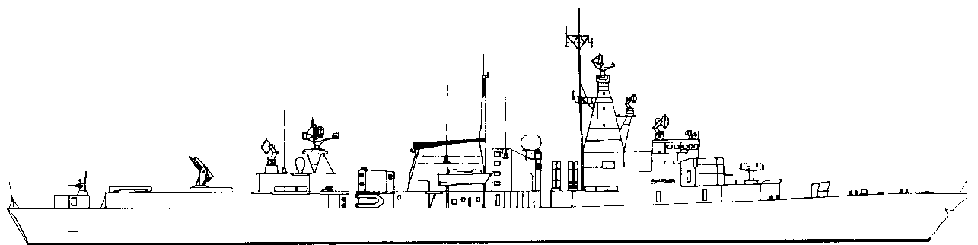
ASW DECOY -3
NOISE +0
Netherlands.
DE RUYTER DDG F 806 3.5 STF
SystemSAFRGLADFADFCDPDFASW1120mm twin410--11-2Harpoon Pt20/860-----3Sonar+2. 4ECM-----4-5SM-1-MR3AB20-44-Hi/Lo6Harpoon Stbd20/860-----7ASWtorps0/74----D5AWRadar48SW Radar39Nato RIM7H
Seasparrow2AB12--13Hi/Vlo0ASWtorps0/74----D5ASWTopPort123Stbd123Mk32MMAA 123456789101112MTF -5HelicopterLynx1ASW type.Harpoon.Port12Stbd.12MTF -3FIREFloodingHELMElectronicsHangarFLIGHT DECK.
NOISE +2
ASW DECOY -3
30kn2520105SUNK
TROMP. DDG F 801 3.5 STF
SystemSAFRGLADFADFCDPDFASW1120mm twin410--11-2Harpoon Pt20/860-----3Sonar+2. 4ECM-----4-5SM-1-MR3AB20-44-Hi/Lo6Harpoon Stbd20/860-----7ASWtorps0/74----D5AWRadar48SW Radar39Nato RIM7H
Seasparrow2AB12--13Hi/Vlo0ASWtorps0/74----D5ASWTorpPort123Stbd123Mk32MMAA 123456789101112MTF -5HelicopterLynx1ASW type.Harpoon.Port12Stbd.12MTF -3FIREFloodingHELMElectronicsHangarFLIGHT DECK.
NOISE +2
ASW DECOY -3
30kn2520105SUNK
30kn2520105SUNK
ASW DECOY -3
NOISE +0
JACOB VAN HEEMSKERCK. Frigate F 812 3 STF
 | System |  |  | SAF |  |  |  | RG |  |  |  |  | LADF |  |  |  |  | ADF |  |  |  |  |  |  | CAD |  |  |  | PDF |  |  |  |  | ASW
1 | Goalkeeper |  |  | 2 |  |  |  | 4 |  |  |  |  | - |  |  |  |  | - |  |  |  |  |  |  | - |  |  |  | 6 |  |  |  |  | -
2 | Harpoon Pt |  |  | 20/8 |  |  |  | 60 |  |  |  |  | - |  |  |  |  | - |  |  |  |  |  |  | - |  |  |  | - |  |  |  |  | -
3 | Sonar |  |  | +2.
4 | ECM |  |  | - |  |  |  | - |  |  |  | - |  |  |  |  |  | - |  |  |  |  |  |  | - |  |  |  | 4 |  |  |  |  | -
5 | SM-1-MR |  |  | 3AB |  |  |  | 20 |  |  |  | - |  |  |  |  |  | 4 |  |  |  |  |  |  | 4 |  |  |  | - |  |  |  |  | Hi/Lo
6 | Harpoon Stbd |  |  | 20/8 |  |  |  | 60 |  |  |  | - |  |  |  |  |  | - |  |  |  |  |  |  | - |  |  |  | - |  |  |  |  | -
7 | ASW torp |  |  | 7 |  |  |  | 6 |  |  |  | - |  |  |  |  |  | - |  |  |  |  |  |  | - |  |  |  | - |  |  |  |  | D6
7 | AWRadar |  |  | 4
8 | SW Radar |  |  | 3
9 | Nato RIM7M  Seasparrow |  |  | 2AB |  |  |  | 15 |  |  |  | - |  |  |  |  |  | - |  |  |  |  |  |  | 1 |  |  |  | 4 |  |  |  |  | Hi/Vlo
0 | ASW torp |  |  | 0/7 |  |  |  | 6 |  |  |  | - |  |  |  |  |  | - |  |  |  |  |  |  | - |  |  |  | - |  |  |  |  | D6
ASW Torps |  |  |  | Port |  |  |  |  | 1 |  |  |  | 2 |  | 3 |  | Stbd |  |  |  |  |  | 1 |  |  |  |  |  | 2 |  | 3 |  | Mk46
Moves MAA |  |  |  | 1 | 2 | 3 |  |  |  | 4 |  |  | 5 |  | 6 |  | 7 |  |  | 8 |  | 9 |  |  |  | 0 |  | 11 |  | 12 |  | MTF -5
Helicopter |  |  | None carried
HARPOON. |  |  | Port |  |  |  | 1 |  |  |  | 2 |  |  | Stbd. |  |  |  |  | 1 |  |  |  |  | 2 |  |  | MTF -3
FIRE |  | FLOODING |  |  |  |  | HELM |  |  |  |  |  |  |  |  |  |  |  |  |  | ELECTRONICS

WITTE DE WITH. Frigate F 813 3 STF
 | System |  |  | SAF |  |  |  | RG |  |  |  |  |  | LADF |  |  |  |  |  |  |  | ADF |  |  |  |  |  |  | CAD |  |  |  | PDF |  |  |  |  | ASW
1 | Goalkeeper |  |  | 2 |  |  |  | 4 |  |  |  |  |  | - |  |  |  |  |  |  |  | - |  |  |  |  |  |  | - |  |  |  | 6 |  |  |  |  | -
2 | Harpoon Pt |  |  | 20/8 |  |  |  | 60 |  |  |  |  |  | - |  |  |  |  |  |  |  | - |  |  |  |  |  |  | - |  |  |  | - |  |  |  |  | -
3 | Sonar |  |  | +2.
4 | ECM |  |  | - |  |  |  | - |  |  |  |  | - |  |  |  |  |  |  |  |  | - |  |  |  |  |  |  | - |  |  |  | 4 |  |  |  |  | Hi/Lo
5 | SM-1-MR |  |  | 3AB |  |  |  | 20 |  |  |  |  | - |  |  |  |  |  |  |  |  | 4 |  |  |  |  |  |  | 4 |  |  |  | - |  |  |  |  | -
6 | Harpoon Stbd |  |  | 20/8 |  |  |  | 60 |  |  |  |  | - |  |  |  |  |  |  |  |  | - |  |  |  |  |  |  | - |  |  |  | - |  |  |  |  | -
7 | ASWtorps |  |  | 7 |  |  |  | 6 |  |  |  |  | - |  |  |  |  |  |  |  |  | - |  |  |  |  |  |  | - |  |  |  | - |  |  |  |  | D6
7 | AWRadar |  |  | 4
8 | SW Radar |  |  | 3
9 | Nato RIM7M  Seasparrow |  |  | 2AB |  |  |  | 15 |  |  |  |  | - |  |  |  |  |  |  |  |  | - |  |  |  |  |  |  | 1 |  |  |  | 4 |  |  |  |  | Hi/Vlo
0 | ASWtorps |  |  | 0/7 |  |  |  | 6 |  |  |  |  | - |  |  |  |  |  |  |  |  | - |  |  |  |  |  |  | - |  |  |  | - |  |  |  |  | D6
ASW Torps |  |  |  | Port |  |  |  |  | 1 |  |  |  |  |  |  |  | 2 |  | 3 |  |  |  |  | Stbd |  |  |  |  |  |  |  | 1 | 2 |  | 3 |  | Mk46
Moves MAA |  |  |  | 1 | 2 | 3 |  |  |  | 4 |  |  |  |  |  | 5 |  | 6 |  |  | 7 |  |  |  | 8 |  | 9 |  |  | 10 |  |  |  | 11 |  | 12 |  |  | MTF-5
Helicopter |  |  | None carried
HARPOON |  |  | Port |  |  |  | 1 |  |  |  | 2 |  |  |  | Stbd. |  |  |  |  |  |  |  | 1 |  |  | 2 |  |  |  |  | MTF -3
FIRE |  | FLOODING |  |  |  |  |  |  |  |  |  | HELM |  |  |  |  |  |  |  |  |  |  |  |  |  |  |  | ELECTRONICS

 | 30kn | 25 | 20 | 10 | 5 | SUNK

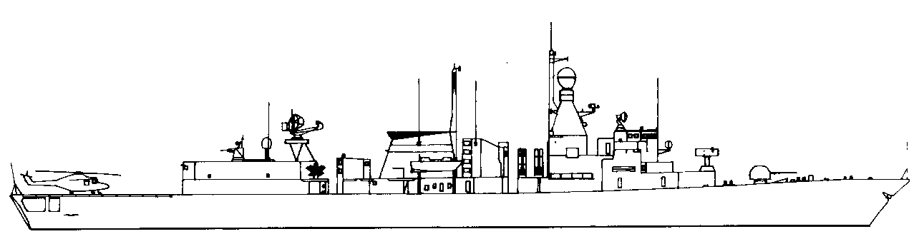
KORTENAER F807 3 STF
SystemSAFRGLADFADFCADPDFASW140mm AA24--11-2Harpoon Pt20/860-----3Sonar+2. +3 if using towed sonar.4ECM-----4Hi/Lo576mmOTO24--31Hi/Vlo6Harpoon Stbd20/860-----7ASWtorps76----D6AWRadar48SW Radar39Nato RIM7M
Seasparrow2AB15--14Hi/Vlo0ASWtorps0/76----D6ASW TorpsPort123Stbd123Mk46Moves MAA12345678MTF-2HelicopterLynxASW type.HARPOONPort12Stbd.12MTF -3FIREFloodingHelmElectronicsHangarFLIGHT DECK.
30kn2520105SUNK
ASW DECOY -3
NOISE +0
JAN VAN BRAKEL F825 3 STF
SystemSAFRGLADFADFCADPDFASW140mm AA24--11-2Harpoon Pt20/860-----3Sonar+2. +3 if using towed sonar.4ECM-----4Hi/Lo576mmOTO24--31Hi/Vlo6Harpoon Stbd20/860-----7ASWtorps76----D6AWRadar48SW Radar39Nato RIM7M
Seasparrow2AB15--14Hi/Vlo0ASWtorps0/76----D6ASW TorpsPort123Stbd123Mk46Moves MAA12345678MTF-2HelicopterLynxASW type.HARPOONPort12Stbd.12MTF -3FIREFloodingHelmElectronicsHangarFLIGHT DECK.
30kn2520105SUNK
ASW DECOY -3
NOISE +0
VAN KINSBERGEN F809 3 STF
SystemSAFRGLADFADFCADPDFASW140mm AA24--11-2Harpoon Pt20/860-----3Sonar+2. +3 if using towed sonar.4ECM-----4Hi/Lo576mmOTO24--31Hi/Vlo6Harpoon Stbd20/860-----7ASWtorps76----D6AWRadar48SW Radar39Nato RIM7M
Seasparrow2AB15--14Hi/Vlo0ASWtorps0/76----D6ASW TorpsPort123Stbd123Mk46Moves MAA12345678MTF-2HelicopterLynxASW type.HARPOONPort12Stbd.12MTF -3FIREFloodingHelmElectronicsHangarFLIGHT DECK.
30kn2520105SUNK
ASW DECOY -3
NOISE +0
CALLENBURGH F809 3 STF
SystemSAFRGLADFADFCADPDFASW1Goalkeeper24---6-2Harpoon Pt20/860-----3Sonar+2. +3 if using towed sonar.4ECM-----4Hi/Lo576mmOTO24--31Hi/Vlo6Harpoon Stbd20/860-----7ASWtorps76----D6AWRadar48SW Radar39Nato RIM7M
Seasparrow2AB15--14Hi/Vlo0ASWtorps0/76----D6ASW TorpsPort123Stbd123Mk46Moves MAA12345678MTF-2HelicopterLynxASW type.HARPOONPort12Stbd.12MTF -3FIREFloodingHelmElectronicsHangarFLIGHT DECK.
30kn2520105SUNK
ASW DECOY -3
NOISE +0
Netherlands.
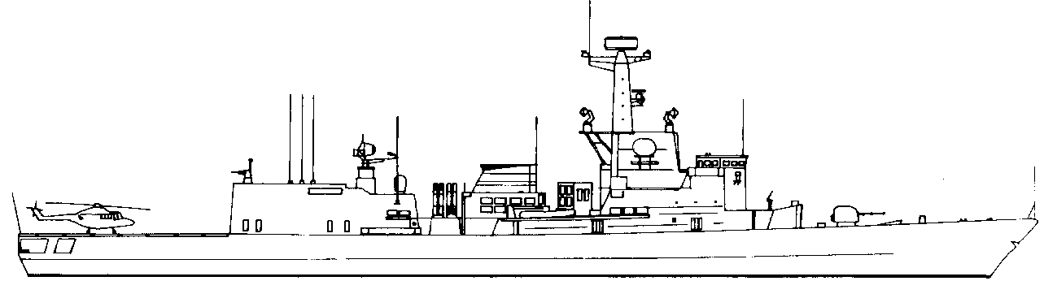
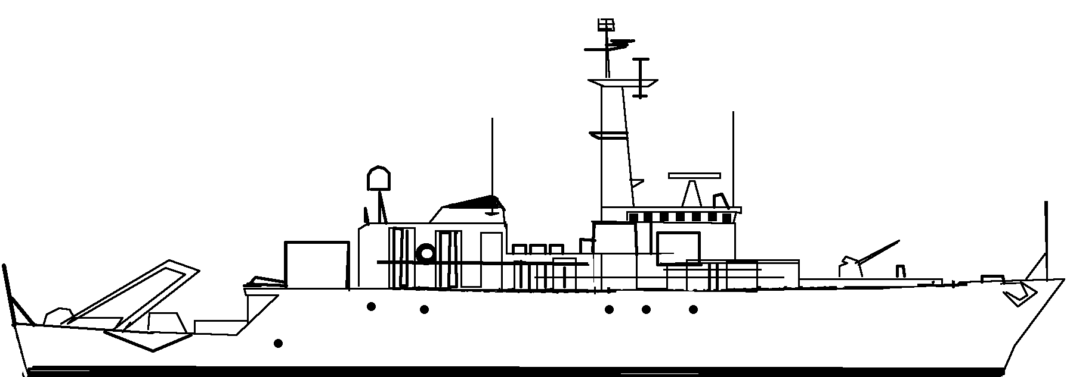
KAREL DOORMAN F827 3.5 STF
SystemSAFRGLADFADFCADPDFASW1Goalkeeper24---6-2Harpoon Pt20/860-----3Sonar+2. +3 if using towed sonar.4ECM-----5Hi/Lo576mmOTO24--31Hi/Vlo6HarpoonStbd20/860-----7ASWtorp76----D6AWRadr48SW Radar39Nato RIM7P
Seasparrow2A15--24Hi/Vlo0ASWtorp0/76----D6ASW TorpsPt123Stbd123Mk46Moves MAA12345678MTF-2HelicopterTwo Lynx carriedASW type.HARPOONPt1234Stbd1234Mtf -3FIREFloodingHelmElectronicsHangarFLIGHT
DECK.
NOISE -1
ASW DECOY -3
30kn2520105SUNK
VAN AMSTEL F831 3.5 STF
SystemSAFRGLADFADFCADPDFASW1Goalkeeper24---6-2Harpoon Pt20/860-----3Sonar+2. +3 if using towed sonar.4ECM-----5Hi/Lo576mmOTO24--31Hi/Vlo6HarpoonStbd20/860-----7ASWtorp76----D6AWRadr48SW Radar39Nato RIM7P
Seasparrow2A15--24Hi/Vlo0ASWtorp0/76----D6ASW TorpsPrt123Stbd123Mk46Moves MAA12345678MTF-2HelicopterTwo Lynx carriedASW type.HARPOONPt1234Stbd1234Mtf -3FIREFloodingHelmElectronicsHangarFLIGHT
DECK.
NOISE -1
ASW DECOY -3
30kn2520105SUNK
TJERK HIDDES F829 3.5 STF
SystemSAFRGLADFADFCADPDFASW1Goalkeeper24---6-2Harpoon Pt20/860-----3Sonar+2. +3 if using towed sonar.4ECM-----5Hi/Lo576mmOTO24--31Hi/Vlo6HarpoonStbd20/860-----7ASWtorp76----D6AWRadr48SW Radar39Nato RIM7P
Seasparrow2A15--24Hi/Vlo0ASWtorp0/76----D6ASW TorpsPrt123Stbd123Mk46Moves MAA12345678MTF-2HelicopterTwo Lynx carriedASW type.HARPOONPt1234Stbd1234Mtf -3FIREFloodingHelmElectronicsHangarFLIGHT
DECK.
NOISE -1
ASW DECOY -3
30kn2520105SUNK
Netherlands.
HAARLEM M853 .5 STF
SystemSAFRGLADFADFCADPDFASW120 mm AA12---1-2SW Radar23AW Radar24SONAR.+3 mine hunting sonar.5Stinger.-1---2-6HMG.1. 5---1-Uses sonar to detect mines in waters up to 80 metres deep. Can tow a minesweeping sled, or normal sweep.
2 PAP 104 MkIV remote controlled mine hunters are carried.FIREFloodingHelm
Stores.
Elect.Fuel
Stores.HangarFLIGHT DECK.
21kn1812105SUNK
NOISE -2
ASW DECOY -2
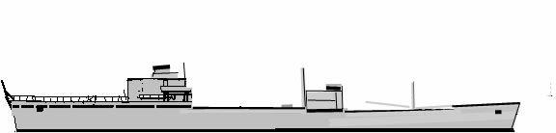
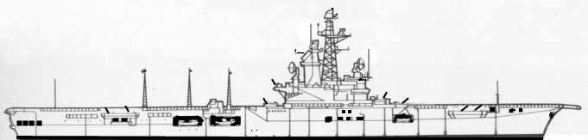
ZUIDERKRUIS A832 8 STF
SystemSAFRGLADFADFCADPDFASW120 mm AA12---1-2SW Radar23AW Radar24ECM-----2Hi/Lo520 mm AA12---1-6RAS positionASW TorpsPort123Stbd123Mk46HelicopterLynx123ASW type.Can support up to five Lynx but only has Hangar space for three.FIREFloodingHelm
Stores.
Elect.Fuel
Stores.HangarFLIGHT DECK.
21kn1812105SUNK
ASW DECOY -2
NOISE +2
Netherlands.
KAREL DOORMAN CVL 1948-68. 13 STF
SystemSAFRGLADFADFCADPDFASW140 mm AA two singles.12---12SW Radar3AW Radar4ECM-----1Hi/Lo40 mm AA two singles.12---1540 mm AA two singles.12---1640mm AA two singles.12---1S2 Tracker.1232 ASW Torps. Etc.Helicopters HSSN-112345ASW type.FIREFloodingHelm
Electronic systemsHangarForward FLIGHT DECK.
Amidships flight Deck.Forward aircraft lift.AFT FLIGHT
DECK.Angled deck.Aft aircraft lift.
25kn1812105SUNK
NO ASW DECOY
NOISE +5
Carried six Sea-Hawk fighters instead of Trackers, if needed.
Large Helicopter capacity enables this ship to provide ASW cover for convoys.
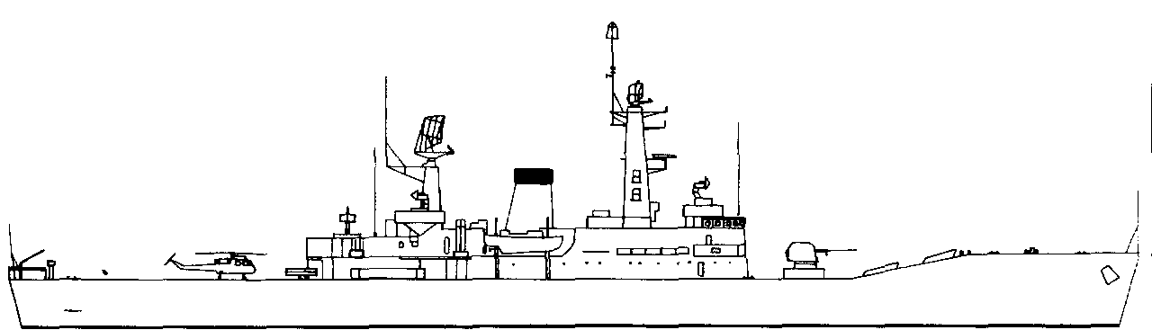
ISAAC SWEERS. Frigate F814 2.5 STF
28kn2520105SUNK
NOISE +1
No Torpedo Decoys
SystemSAFRGLADFADFCADPDFASW176mm OTO24--31-2Harpoon Port20/860-----Sonar+2. +3 if using towed sonar.3ECM-----2-4SEACAT2/32.5---3Lo/ VloHarpoon Stbd20/860-----5ASW Torps76----D6AW Radar3------6SW Radar3------ASW torpsPort123Stbd123Mk46Moves MAA12345678MTF -0HelicopterWASP HAS.1ASW type.HARPOON.Port12Stbd.12MTF -3FIREFLOODINGHELMELECTHANGARFLIGHT DECK.
EVERTSEN. Frigate F815 2.5 STF
28kn2520105SUNK
NOISE +1
No Torpedo Decoys
SystemSAFRGLADFADFCADPDFASW176mm OTO24--31-2Harpoon Port20/860-----Sonar+2. +3 if using towed sonar.3ECM-----2-4SEACAT2/32.5---3Lo/ VloHarpoon Stbd20/860-----5ASW Torps76----D6AW Radar3------6SW Radar3------ASW torpsPort123Stbd123Mk46Moves MAA12345678MTF -0HelicopterWASP HAS.1ASW type.HARPOON.Port12Stbd.12MTF -3FIREFLOODINGHELMELECTHANGARFLIGHT DECK.
Netherlands.
ABRAHAM CRIJNSSEN F816 3 STF
SystemSAFRGLADFADFCADPDFASW140mm AA24--11-2Harpoon Pt20/860-----3Sonar+2. +3 if using towed sonar.4ECM-----4Hi/Lo576mmOTO24--31Hi/Vlo6Harpoon Stbd20/860-----7ASWtorps76----D6AWRadar48SW Radar39Nato RIM7M
Seasparrow2AB12--14Hi/Vlo0ASWtorps0/76----D6ASW TorpsPort123Stbd123Mk46Moves MAA12345678MTF-2HelicopterLynxASW type.HARPOONPort12Stbd.12MTF -3FIREFloodingHelmElectronicsHangarFLIGHT DECK.
30kn2520105SUNK
ASW DECOY -3
NOISE +0
PIET HEIN F811 3 STF
SystemSAFRGLADFADFCADPDFASW140mm AA24--11-2Harpoon Pt20/860-----3Sonar+2. +3 if using towed sonar.4ECM-----4Hi/Lo576mmOTO24--31Hi/Vlo6Harpoon Stbd20/860-----7ASWtorps76----D6AWRadar48SW Radar39Nato RIM7M
Seasparrow2AB12--14Hi/Vlo0ASWtorps0/76----D6ASW TorpsPort123Stbd123Mk46Moves MAA12345678MTF-2HelicopterLynxASW type.HARPOONPort12Stbd.12MTF -3FIREFloodingHelmElectronicsHangarFLIGHT DECK.
30kn2520105SUNK
ASW DECOY -3
NOISE +0

