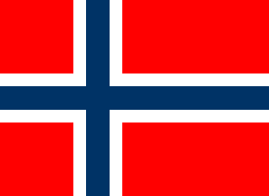
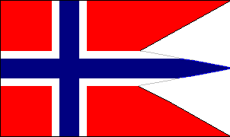
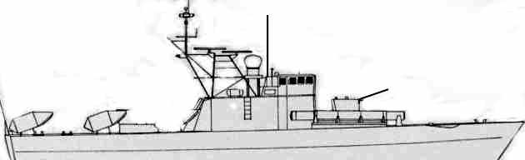
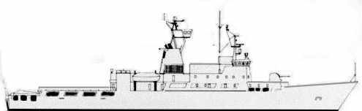
NORWAY
SNOGG P980. .25 STF
32kn2515105SUNK
No ASW DECOY
SystemAFRGLADFADFCADPDFAsw1Sonar+1.2ECM-----1-3Penguin 1.516-----4Torpedoes.0/105-----5AW Radar36SW Radar340mm/7024--11-T61 wire guided torpedoes.123470% to hit.Penguin 1 SSM Aft.1234 -3 MTF. Flies low.FIREFloodingHELMElectronics
Very small. At 25knots or over,
INCOMING missiles hit % reduced half.
NOISE +2 over 25 knots.
SNAR P982. .25 STF
32kn2515105SUNK
No ASW DECOY
SystemAFRGLADFADFCADPDFAsw1Sonar+1.2ECM-----1-3Penguin 1.516-----4Torpedoes.0/105-----5AW Radar36SW Radar340mm/7024--11-T61 wire guided torpedoes.123470% to hit.Penguin 1 SSM Aft.1234 -3 MTF. Flies low.FIREFloodingHELMElectronics
Very small. At 25knots or over,
INCOMING missiles hit % reduced half.
NOISE +2 over 25 knots.
NORDKAPP W320. 2.5 STF
SystemAFRGLADFADFCADPDFAsw1Fire fighting equipment.220mm RM20.5113Sonar+1.4ECM-----2-520mm RM20.5116Penguin 1I.520-----7DC rack.10POD18AW Radar39SW Radar3057mm/7017--21-ASW.Port123Stbd123Mk32Penguin 1. SSM Aft.1234 -3 MTF. SSk.FIREFloodingHELMElectronicsHangarFLIGHT DECK
Strengthened hull. Fitted for ice navigation. Ship is not an icebreaker.
NORDKAPP is shown with war armament.
Fitted out as a fire fighting vessel.
23kn2015105SUNK
NOISE +1
No ASW DECOY
A versatile vessel designed to act as a border guard unit, rescue and fire fighting ship, or a wartime escort.
ONE helicopter carried in hangar. Can support two.
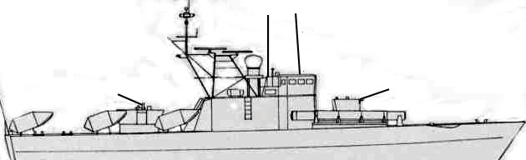
RAVN P996. .25 STF
SystemAFRGLADFADFCADPDFAsw1Sonar+1.2ECM-----1-20mm RM20.5113Penguin 1I.520-----4Torpedoes.0/105-----5AW Radar36SW Radar340mm/7024--11-T61 wire guided torpedoes.1270% to hit.Penguin 1I. SSM Aft.123456 -3 MTF. SSk.FIREFloodingHELMElectronics
32kn2515105SUNK
NOISE +2 over 25 knots.
No ASW DECOY
ORN P987. .25 STF
SystemAFRGLADFADFCADPDFAsw1Sonar+1.2ECM-----1-20mm RM20.5113Penguin 1I.520-----4Torpedoes.105-----5AW Radar36SW Radar340mm/7024--11-T61 wire guided torpedoes.1270% hit.Penguin 1I. SSM Aft.123456 -3 MTF. SSk.FIREFloodingHELMElectronics
32kn2515105SUNK
TJELD P989. .25 STF
SystemAFRGLADFADFCADPDFAsw1Sonar+1.2ECM-----1-20mm RM20.5113Penguin 1I.520-----4Torpedoes.0/105-----5AW Radar36SW Radar340mm/7024--11-T61 wire guided torpedoes.1270% to hit.Penguin 1I. SSM Aft.123456 -3 MTF. SSk.FIREFloodingHELMElectronics
Very small. At 25knots or over,
INCOMING missiles hit % reduced half.
TERNE P988. .25 STF
SystemAFRGLADFADFCADPDFAsw1Sonar+1.2ECM-----1-20mm RM20.5113Penguin 1I.520-----4Torpedoes.0/105-----5AW Radar36SW Radar340mm/7024--11-T61 wire guided torpedoes.1270% to hit.Penguin 1I. SSM Aft.123456 -3 MTF. SSk.FIREFloodingHELMElectronics
Very small. At 25knots or over,
INCOMING missiles hit % reduced half.
FALK P995. .25 STF
SystemAFRGLADFADFCADPDFAsw1Sonar+1.2ECM-----1-20mm RM20.5113Penguin 1I.520-----4Torpedoes.0/105-----5AW Radar36SW Radar340mm/7024--11-T61 wire guided torpedoes.1270% to hit.Penguin 1I. SSM Aft.123456 -3 MTF. SSk.FIREFloodingHELMElectronics
Very small. At 25knots or over,
INCOMING missiles hit % reduced half.
32kn2515105SUNK
NOISE +2 over 25 knots.
No ASW DECOY
STEGG, ORN, RAVN, TJELD, FALK, TERN.
NORWAY

NOISE +2 over 25 knots.

No ASW DECOY
 | 32kn | 25 | 15 | 10 | 5 | SUNK

STEGG P994. .25 STF

NOISE +2 over 25 knots.

No ASW DECOY
Very small. At 25knots or over,
INCOMING missiles hit % reduced half.
 | System |  | AF | RG |  |  | LADF |  |  |  |  |  | ADF |  |  | CAD |  |  | PDF | Asw
1 | Sonar |  | +1.
2 | ECM |  | - | - |  |  | - |  |  |  |  |  | - |  |  | - |  |  | 1 | -
2 | 20mm RM20 |  | .5 | 1 |  |  |  |  |  |  |  |  |  |  |  |  |  |  | 1
3 | Penguin 1I. |  | 5 | 20 |  |  | - |  |  |  |  |  | - |  |  | - |  |  | - | -
4 | Torpedoes. |  | 0/10 | 5 |  |  | - |  |  |  |  |  | - |  |  | - |  |  | - | -
5 | AW Radar |  | 3
6 | SW Radar |  | 3
6 | 40mm/70 |  | 2 | 4 |  | - |  |  |  |  |  |  | - |  |  | 1 |  |  | 1 | -
T61 wire guided torpedoes. |  |  |  |  |  |  |  |  |  | 1 |  |  | 2 |  |  |  |  | 70% to hit.
Penguin 1I. SSM Aft. |  |  |  | 1 | 2 |  |  | 3 | 4 |  | 5 | 6 |  | -4 MTF. Surface skimmer.
FIRE |  | Flooding |  | HELM |  |  |  |  |  |  |  |  | Electronics

 | 32kn | 25 | 15 | 10 | 5 | SUNK

NOISE +2 over 25 knots.

No ASW DECOY
Very small. At 25knots or over,
INCOMING missiles hit % reduced half.
Very small. At 25knots or over,
INCOMING missiles hit % reduced half.
 | 32kn | 25 | 15 | 10 | 5 | SUNK

No ASW DECOY

NOISE +2 over 25 knots.
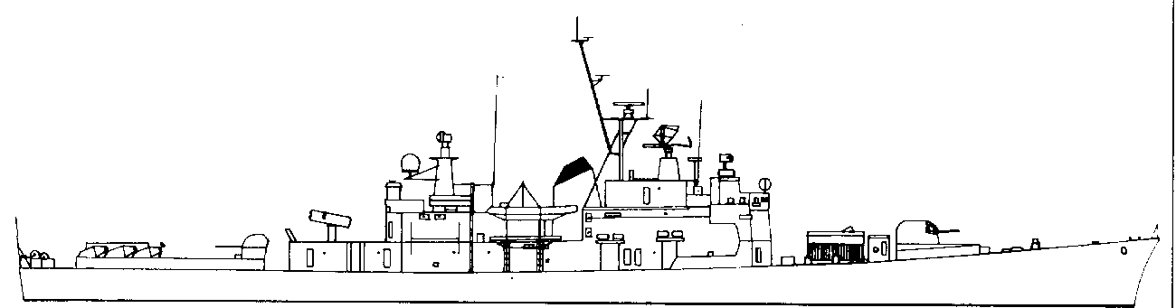
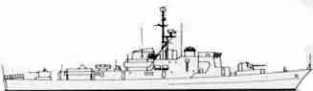
OSLO F300. 2 STF
SystemAFRGLADFADFCADPDFAsw13” Mk33 twin 23--2--2Nato RIM7H
Seasparrow2AB12--14Hi/Vlo3Sonar+1.4ECM-----2-5Penguin 1.516-----6ASW Torp0/105----D/77AW Radar28SW Radar2940mm/7024--11-0TERNE ASW Mortar.0/101.5----Sh.3ASW.Port12Stbd12Mk32Penguin 1. SSM Aft.1234 -3 MTF. SSk.FIREFloodingHELMElectronicsMoves MAA123456 MTF -2
NOISE +1
No ASW DECOY
NORWAY
NARVIK F304. 2 STF
SystemAFRGLADFADFCADPDFAsw13” Mk33 twin 23--2--2Nato RIM7H
Seasparrow2AB12--14Hi/Vlo3Sonar+1.4ECM-----2-20mm RM20.5115Penguin 1.516-----6ASW Torp0/105----D/77AW Radar28SW Radar2940mm/7024--11-0TERNE ASW Mortar.0/101.5----Sh.3ASW.Port12Stbd12Mk32Penguin 1. SSM Aft.1234 -3 MTF. SSk.FIREFloodingHELMElectronicsMoves MAA123456 MTF -2
25kn2015105SUNK
NOISE +1
No ASW DECOY
TRONDHEIM F302. 2 STF
SystemAFRGLADFADFCADPDFAsw13” Mk33 twin 23--2--2Nato RIM7H
Seasparrow2AB12--14Hi/Vlo3Sonar+1.4ECM-----2-20mm RM20.5115Penguin 1I.520-----6ASW Torp0/105----D/77AW Radar38SW Radar3940mm/7024--11-0TERNE ASW Mortar.0/101.5----Sh.3ASW.Port123Stbd123Mk32Penguin 1. SSM Aft.1234 -3 MTF. SSk.FIREFloodingHELMElectronicsMoves MAA123456 MTF -2
25kn2015105SUNK
NOISE +1
No ASW DECOY
SLEIPNER F302. 1 STF
SystemAFRGLADFADFCADPDFAsw13” Mk34 single 13--1--2DC rack.10POD13Sonar+1.4TERNE ASW Mortar.0/101.5----Sh.340mm/7024--11-5ASW Torp0/105----D/7AW Radar16SW Radar1ASW.Port12Stbd12Mk32FIREFloodingHELMElectronics
22kn2015105SUNK
NOISE +1
No ASW DECOY
 | 25kn | 20 | 15 | 10 | 5 | SUNK

