 | System |  |  | SAF |  |  | RG |  |  | LADF |  |  |  |  | ADF |  |  | CAD |  |  |  | PDF |  | ASW
1 | MEROKA |  |  | - |  |  | - |  |  | - |  |  |  |  | - |  |  | - |  |  |  | 5 |  | -
2 | MEROKA |  |  | - |  |  | - |  |  | - |  |  |  |  | - |  |  | - |  |  |  | 5 |  | -
3 | Sonar |  |  | +2.
4 | ECM |  |  | - |  |  | - |  |  | - |  |  |  |  | - |  |  | - |  |  |  | 5 |  | -
5 | SW Radar |  |  | 4
6 | AW Radar. 4
AV-8 Matador. |  |  | 1 |  | 2 | 3 |  | 4 | 5 |  | 6 |  | 7 | 8 |  | 9 | 10 |  | 11 |  | 12 |  | Maximum load.
SH-10 Sea King. |  |  | 1 |  | 2 | 3 |  | 4 | 5 |  | 6 |  | 7 | 8 |  | 9 | 10 |  | Maximum load.
AB212 ASW/EW. |  |  | 1 |  | 2 | 3 |  | 4 | Maximum load.
FIRE |  | Flooding |  |  |  |  |  |  |  |  |  | Helm |  |  |  |  |  |  |  | Electronics
FORWARD LIFT. |  | AFT LIFT |  |  |  |  |  |  |  |  |  | FLIGHT DECK |  |  |  |  |  |  |  | HANGAR.
FORWARD FLIGHT DECK. |  | AFT FLIGHT DECK.  Normally carries only four AV-8 aircraft, plus six SH10 and two AB212 helicopters. War load would be a mix of the above types depending upon the mission to be carried out. If all the AV8 are carried there is only room for two helicopters.
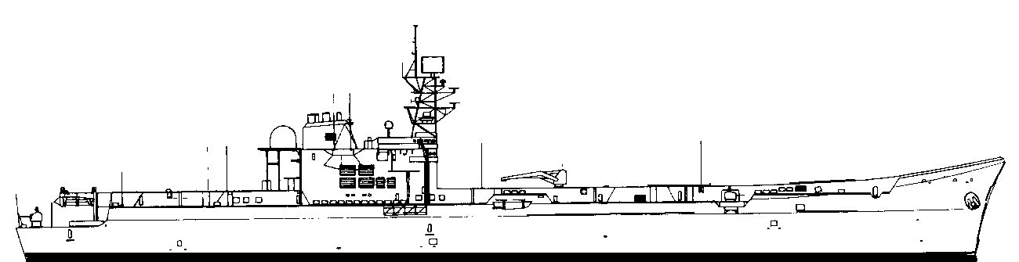
PRINCIPE DE ASTURIAS. R-11 16. STF
26 Knots.2015105SUNK
 | 27kn | 25 | 20 | 10 | 5 | SUNK
 | 29kn | 25 | 20 | 10 | 5 | SUNK

Meroka are positioned to fire as pairs in any one direction. Eight are carried in total.
 | System |  |  |  | SAF |  | RG |  | LADF |  |  |  | ADF |  | CAD | PDF |  | ASW
1 | 40mm twin |  |  |  | 1.5 |  | 2 |  |  | - |  |  |  | - |  | 1 |  | -
2 | 40mm twin |  |  |  | 1.5 |  | 2 |  | - |  |  |  |  |  | - | 1 |  | -
3 | Sonar |  |  |  | +2.
4 | ECM |  |  |  | - |  | - |  | - |  |  |  |  |  | - | 2 |  | -
5 | SW Radar |  |  |  | 4
6 | 40mm twin. |  |  |  | 1.5 |  | 2 |  | - |  |  |  |  |  | - | 1 |  | -
7 | 40mm twin. |  |  |  | 1.5 |  | 2 |  | - |  |  |  |  |  | - | 1 |  | -
8 | 40mm quad |  |  |  | 2 |  |  |  |  |  |  |  |  |  | - | 2
9 | 40mm twin |  |  |  | 1.5 |  | 2 |  | - |  |  |  |  |  | - | 1 |  | -
10 | AW Radar
AV-8 Matador. |  | 1 | 2 |  |  | 3 |  | 4 |  |  | Maximum load.
SH-3D Sea King. |  | 1 | 2 |  |  | 3 |  | 4 |  |  | Maximum load.
AB212 ASW/EW. |  | 1 | 2 |  |  | 3 |  | 4 |  |  | Maximum load.
FIRE |  |  |  | Flooding |  |  |  |  |  |  |  | Helm |  |  |  |  | Electronics
FORWARD LIFT. |  |  |  | AFT LIFT |  |  |  |  |  |  |  | FLIGHT DECK |  |  |  |  | HANGAR.
FORWARD FLIGHT DECK. |  |  |  | AFT FLIGHT DECK.
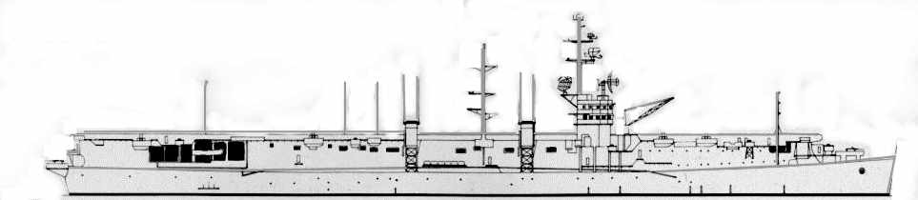
DEDALO. R-01 13. STF
30 Knots.2515105SUNK
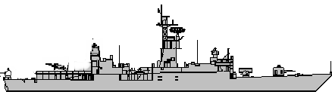
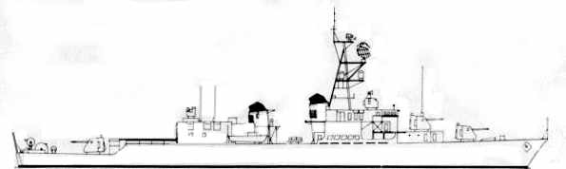
27kn2520105SUNK
BALEARES (as 1981). FFG 71 3 STF
F807 3 STF
ASW DECOY 3
SystemSAFRGLADFADFCADPDFASW15” Mk42313--31-2SM-1-MR3AB20-44--3Sonar+3 4ECM-----3-5ASWtorps76----VD66HARPOON2060-----7AW Radar38SW Radar49ASROCVD60MEROKA-----5-ASW TorpsPort123Stbd123Mk46Moves MAA123456789MTF-4HARPOON.Port12345678MTF -3FIREFloodingHelmElectronicsFLIGHT
DECKHANGAR
NOISE -1
27kn2520105SUNK
ASTURIAS (as 1981). FFG 74 3 STF
F807 3 STF
ASW DECOY 3
SystemSAFRGLADFADFCADPDFASW15” Mk42313--31-2SM-1-MR3AB20-44--3Sonar+3 4ECM-----3-5ASWtorps76----VD66HARPOON2060-----7AW Radar38SW Radar49ASROCVD60MEROKA-----5-ASW TorpsPort123Stbd123Mk46Moves MAA123456789MTF-4HARPOON.Port12345678MTF -3FIREFloodingHelmElectronicsFLIGHT
DECKHANGAR
NOISE -1
ESTRAMADURA (as 1981). FFG 77 3 STF
F807 3 STF
ASW DECOY 3
SystemSAFRGLADFADFCADPDFASW15” Mk42313--31-2SM-1-MR3AB20-44--3Sonar+3 4ECM-----3-5ASWtorps76----VD66HARPOON2060-----7AW Radar38SW Radar49ASROCVD60MEROKA-----5-ASW TorpsPort123Stbd123Mk46Moves MAA123456789MTF-4HARPOON.Port12345678MTF -3FIREFloodingHelmElectronicsFLIGHT
DECKHANGAR
NOISE -1
27kn2520105SUNK
33kn2520105SUNK
Marques De la Ensenada. DD 3 STF
SystemSAFRGLADFADFCADPDFASW15” twin 410--11-ASW Torps0/74----D52Sonar+1. 3ECM-----1-45” twin 410--11-5ASW Torps0/76----VD6AW Radar36SW Radar35” twin 410--11-ASW TorpPort123Stbd123Mk32FIREFloodingHELMElectronics
 | MM38 EXOCET. | 1 |  | 2 | 3 | 4
SA-319B Alouette III. Helicopter. |  |  | 1 Carried. ASW

ASW DECOY -2

NOISE +3
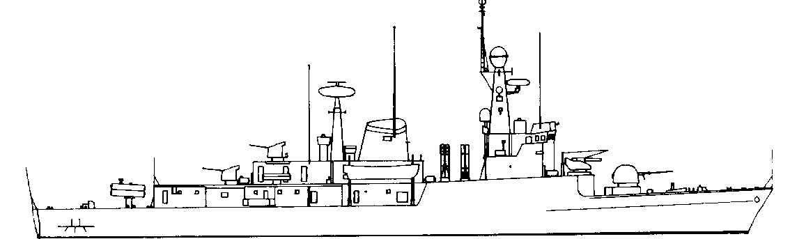
DESCUBIERTA. (as 1978). F-31 1.5 STF

3 STF
F807 3 STF
SystemSAFRGLADFADFCADPDFASW140mm 12---1-240mm 12---1-3Sonar+2. 4ECM-----3-576mm
OTO24--31Hi/Vlo6HARPOON25130-----7ASW torp76----D6AW Radar48SW Radar49Seasparrw415---4Hi/Vlo0375mm RL0/101----D4ASW TorpsPort123Stbd123Mk46Moves MAA123456789MTF-3HARPOON.1234Stbd.1234MTF -4FIREFloodingHelmElectronics
26kn2015105SUNK
NOISE 0
ASW DECOY -2
DIANA. (as 1979). F-32 1.5 STF

3 STF
F807 3 STF
SystemSAFRGLADFADFCADPDFASW140mm 12---1-240mm 12---1-3Sonar+2. 4ECM-----3-576mm
OTO24--31Hi/Vlo6HARPOON25130-----7ASW torp76----D6AW Radar48SW Radar49Seasparrw415---4Hi/Vlo0375mm RL0/101----D4ASW TorpsPort123Stbd123Mk46Moves MAA123456789MTF-3HARPOON.1234Stbd.1234MTF -4FIREFloodingHelmElectronics
26kn2015105SUNK
NOISE 0
ASW DECOY -2
CAZADORA. (as 1981). F-35 1.5 STF

3 STF
F807 3 STF
SystemSAFRGLADFADFCADPDFASW140mm 12---1-240mm 12---1-3Sonar+2. 4ECM-----3-576mm
OTO24--31Hi/Vlo6HARPOON25130-----7ASW torp76----D6AW Radar48SW Radar49Seasparrow415---4Hi/Vlo0375mm RL0/101----D4ASW TorpsPort123Stbd123Mk46Moves MAA123456789MTF-3HARPOON.1234Stbd.1234MTF -4FIREFloodingHelmElectronics
26kn2015105SUNK
NOISE 0
ASW DECOY -2
INFANTA CRISTINA (as 1980) F-34 1.5 STF

3 STF
F807 3 STF
SystemSAFRGLADFADFCADPDFASW140mm 12---1-240mm 12---1-3Sonar+2. 4ECM-----3-576mmOTO24--31Hi/Vlo6HARPOON25130-----7ASW torp76----D6AW Radar48SW Radar49Seasparrow415---4Hi/Vlo0375mm RL0/101----D4ASW TorpsPort123Stbd123Mk46Moves MAA123456789MTF-3HARPOON.1234Stbd.1234MTF -4FIREFloodingHelmElectronics
26kn2015105SUNK
NOISE 0
ASW DECOY -2
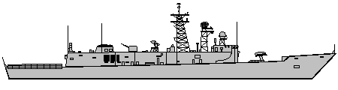
SANTA MARIA (as 1986). FFG 81 2 STF
F807 3 STF
ASW DECOY 3
SystemSAFRGLADFADFCADPDFASW176mmOTO24--31-2SM-1-MR3AB20-66--3Sonar+1 4ECM-----4-5ASWtorps76----VD66HARPOON2060-----7AW Radar38SW Radar49ASROC56VD60MEROKA-----5-ASW TorpsPort123Stbd123Mk46Moves MAA1234567MTF-4HARPOON.Port12345678MTF -3FIREFloodingHelmElectronicsFLIGHT
DECKHANGAR
NOISE -1
29kn2520105SUNK
NUMANCIA (as 1988). FFG 81 2 STF
F807 3 STF
ASW DECOY 3
SystemSAFRGLADFADFCADPDFASW176mmOTO24--31-2SM-1-MR3AB20-66--3Sonar+1 4ECM-----4-5ASWtorps76----VD66HARPOON2060-----7AW Radar38SW Radar49ASROC56VD60MEROKA-----5-ASW TorpsPort123Stbd123Mk46Moves MAA1234567MTF-4HARPOON.Port12345678MTF -3FIREFloodingHelmElectronicsFLIGHT
DECKHANGAR
NOISE -1
29kn2520105SUNK

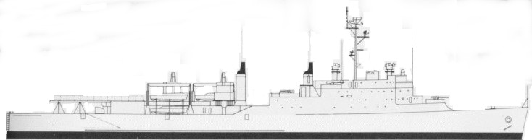
15121085SUNK
SystemSAFRGLADFADFCADPDFASW140mm quad2-22Sonar+1. 3ECM-----1-440mm twin1.52--1-5AW Radar36SW Radar340mm twin1.52--1-ASW TorpPort123Stbd123Mk32Landing craftStores.Troops.Ammunition.FIREFloodingHELMElectronics
GALICIA LSD. 4 SDF
CONDE DEL VENADITO 2 STF
SystemSAFRGLADFADFCADPDFASW1ECM0240mm twin1.52--1-34AW Radar25SW Radar2640mm twin1.52--1-FIREFloodingHELMElect.TROOPS.CARGO.
16kn121085SUNK
NOISE +2
NO ASW DECOY

